|  |  |  |
| --- | --- | --- |
| **Table of Content** | | |
| **Sno.** | **Topic** | **Page No.** |
| **1** | ABSTRATCT. | 1 |
| **2** | INTRODUCTION. | 2 |
| **3** | EXISTING SYSTEM. | 3 |
| **4** | PROPOSED SYSTEMS. | 4 |
| **5** | ARCHITECTURE TECHNIQUES. | 6 |
| **6** | METHODOLOGY. | 7 |
| **7** | IMPLEMENTATION. | 9 |
| **8** | CODE & VISUALISATION. | 12 |
| **9** | IMAGES. | 54 |
| **10** | EXECUTION & OUTPUT. | 54 |
| **11** | TOOLS. | 63 |
| **12** | CONCLUSION. | 65 |
| **13** | REFERENCE. | 66 |

**ABSTRACT:**

The global shipping sector, which stands as a fundamental component of worldwide trade, heavily relies on robust web technologies to streamline its operations, improve the customer experience, and optimize logistics. This project embarks on an investigation into web technologies customized to address the unique challenges and requirements of global shipping services.

The primary aim of this project is to create a comprehensive web-based solution that seamlessly integrates both front-end and back-end technologies, effectively catering to the multifaceted demands of the shipping industry. The focus of the front-end is on developing a user-friendly design, providing an intuitive and engaging interface for customers to access services, track shipments, and obtain real-time information. Conversely, the back-end system is meticulously designed to manage the intricacies of logistics, encompassing tasks ranging from order processing and inventory management to upholding data security and ensuring smooth communication among diverse stakeholders.

The project will encompass the application of cutting-edge web technologies, including HTML, CSS, JavaScript, and responsive design frameworks, with the objective of creating a visually pleasing and user-friendly front-end interface. In the realm of back-end development, a synergy of programming languages and databases will be employed, with a strong emphasis on data integrity, scalability, and the implementation of robust security protocols.

Throughout the duration of this project, a critical examination of case studies and real-world instances within the global shipping industry will be undertaken, shedding light on the pragmatic utilization of web technologies to address industry-specific challenges. By delivering this integrated web solution, our intention is to underscore the pivotal role played by web technologies in enhancing global shipping services, thereby guaranteeing timely deliveries and elevating customer satisfaction.

This project not only offers a valuable hands-on experience in web development but also underscores the significance of innovation and technology in the ever-evolving landscape of global shipping services. In a world where efficient and seamless shipping solutions are increasingly indispensable, the insights derived from this project will actively contribute to the continual refinement of global supply chain operations and the enhancement of overall customer satisfaction.

**Key words:**

Global Shipping Sector, Web Technologies, HTML, CSS, JavaScript, Twitter, Facebook, Instagram, WhatsApp, tweepy, Global Shipping Sector Search words,

**Introduction:**

In an era characterized by unparalleled connectivity and the rapid globalization of trade and commerce, the global shipping industry has evolved to become the lifeblood of international business. To keep pace with the ever-growing demands of this dynamic sector, the implementation of cutting-edge web technologies is not merely an advantage; it is an absolute necessity. This project sets sail into the expansive world of web technologies as applied to global shipping services, where the digital realm meets the physical logistics domain, revolutionizing the way we move goods around the world.

The integration of web technologies into the realm of global shipping services has ushered in an era of unprecedented efficiency, transparency, and customer convenience. Through the development of web-based solutions, this project aims to explore the multifaceted aspects of enhancing both front-end and back-end functionalities to streamline operations, improve the user experience, and ensure the secure and seamless transport of goods across the globe.

**Objectives:**

* **Front-End Excellence:** We will delve into the art and science of front-end development, focusing on creating user-friendly interfaces that empower customers and stakeholders to effortlessly navigate the complexities of global shipping. This includes an exploration of responsive design, user experience (UX) enhancements, and cutting-edge web design techniques.
* **Challenges and Solutions:** The report will address the challenges posed by the global shipping industry, including scalability, data security, and the need for real-time tracking, offering innovative solutions and best practices.

**Problem Statement:**

In an era of globalized trade and interconnected economies, the efficiency and effectiveness of global shipping services are paramount. The need to develop a robust web-based platform for global shipping services arises from the demand for a seamless, user-friendly, and secure system that facilitates international trade and logistics operations.

This project seeks to address the following key challenges:

**User Experience Enhancement:** Global shipping services have traditionally been marred by complex and confusing user interfaces. Customers often struggle with tracking shipments, calculating costs, and finding information. The challenge is to create a website that provides an intuitive and user-friendly experience, simplifying the process for customers and increasing user satisfaction.

**Real-Time Tracking:** As global shipping involves multiple parties and complex logistics, real-time tracking of shipments is essential. The problem is to develop a web-based system that can accurately and efficiently track shipments throughout their journey, providing real-time updates to customers and stakeholders.

**Data Security and Privacy:** The global shipping industry deals with sensitive data, including customer information, shipment details, and financial transactions. The challenge is to ensure the highest level of data security and privacy, safeguarding against breaches and unauthorized access.

**Scalability:** Global shipping services often experience fluctuations in demand, requiring scalable web technologies to handle varying workloads efficiently. The problem is to design a system that can handle high traffic during peak seasons and scale down during quieter periods without compromising performance.

**Existing System:**

* **FedEx** (<https://www.fedex.com>): FedEx, a prominent global shipping and logistics enterprise, furnishes a suite of online tools to enable customers to monitor shipments, solicit quotes, and arrange pickups.
* **UPS** (<https://www.ups.com>): United Parcel Service (UPS) provides an online platform tailored to shipping, tracking parcels, and administering shipments.
* **DHL** (<https://www.dhl.com>): DHL, a purveyor of international shipping and logistics services, delivers an online gateway for overseeing tracking and shipping management.
* **Maersk** (<https://www.maersk.com>): Maersk, a global shipping conglomerate, extends online services for the reservation of shipments, tracking container statuses, and logistics management.
* **Ship Station** (<https://www.shipstation.com>): Ship Station stands as a software platform designated for shipping, fostering integration with numerous carriers and e-commerce platforms to streamline shipping operations for businesses.
* **Cargo Smart** (<https://www.cargosmart.com>): Cargo Smart extends solutions for global shipping and logistics management, encompassing aspects like tracking, visibility, and data analytics.
* **Ship Hawk** (<https://www.shiphawk.com>): Ship Hawk offers solutions for shipping and transportation, encompassing a platform that simplifies shipment management and quote generation.
* **U Ship** (<https://www.uship.com>): u Ship operates as an online marketplace connecting customers with carriers, facilitating a wide array of shipment types.
* **Easy ship** (<https://www.easyship.com>): Easy ship provides a platform designed to streamline global shipping by furnishing information on shipping rates, tracking capabilities, and label generation.

**Proposed Systems:**

Proposing a system for global shipment services involves outlining the key components and features that should be part of the system to ensure efficiency, customer satisfaction, and seamless operations. Below, I'll provide an overview of the proposed systems for global shipment services:

* **Shipment Tracking System:**

Real-time tracking of shipments from origin to destination.

Integration with GPS and other tracking technologies.

Providing customers with status updates and estimated delivery times.

Alerts and notifications for any delays or issues.

* **User-Friendly Web Interface:**

A well-designed front-end web interface for customers to book, track, and manage shipments easily.

Mobile responsiveness to cater to both desktop and mobile users.

Clear and intuitive navigation.

* **Automated Quotation and Pricing System:**

Online tools for customers to get instant quotes for shipping services.

Pricing calculators that consider factors like package weight, dimensions, destination, and shipping method.

Integration with real-time currency exchange rates and various pricing models (e.g., flat rate, variable rate, etc.).

* **Secure User Accounts:**

User registration and authentication.

Secure storage of customer information.

Options for customers to save addresses, payment details, and preferences for a streamlined booking process.

* **Online Booking and Payment Processing:**

A booking system that allows customers to select shipping options, schedule pickups, and make payments online.

Integration with various payment gateways for secure transactions.

Automated confirmation and receipts.

* **Warehouse and Inventory Management:**

Systems for managing warehouse operations and inventory.

Barcode scanning and RFID for tracking items in real-time.

Inventory optimization to prevent overstocking or stockouts.

* **Customs Clearance and Compliance:**

Integration with customs systems for seamless customs clearance.

Ensuring compliance with international shipping regulations.

Automated documentation generation for customs purposes.

* **Customer Support and Communication:**

A customer support portal with chat, email, and phone support options.

Automated email and SMS notifications to keep customers informed about their shipments.

AI-driven chatbots for basic inquiries and support.

* **Performance Analytics and Reporting:**

Tracking system performance and generating reports for key performance indicators (KPIs).

Data analytics for optimizing routes, identifying bottlenecks, and improving overall efficiency.

* **Security and Data Protection:**

Robust security measures to protect customer data, financial information, and shipment details.

Data encryption, secure login protocols, and regular security audits.

* **Multilingual and Multi-currency Support:**

Support for multiple languages and currencies to cater to a global customer base.

Currency conversion tools for seamless international transactions.

* **Scalability and Redundancy:**

Scalable architecture to accommodate increased demand.

Redundancy in data storage and server infrastructure to ensure system reliability.

* **Integration with Shipping Carriers:**

Integration with major shipping carriers (e.g., UPS, FedEx, DHL) to provide a wide range of shipping options.

Real-time rate and route information from these carriers.

* **Regulatory Compliance and Sustainability:**

Compliance with international shipping regulations and standards.

Consideration of eco-friendly and sustainable shipping options and practices.

This proposed system for global shipment services should serve as a foundation for building a comprehensive and competitive shipping platform. The actual implementation and features may vary depending on the specific needs and goals of the shipping service provider.

**System Analysis:**

A system analysis of global shipment services involves a comprehensive examination of how technology and systems can enhance the efficiency, accuracy, and overall effectiveness of the processes related to shipping goods across the world.

* **Stakeholders and User Analysis:**

Identify all the people and organizations involved in global shipments. Understand their needs and challenges.

* **Requirements Analysis:**

What do we want the system to do? This section outlines the specific features and functionalities we need. Think about shipment tracking, data management, and user interfaces.

* **System Architecture:**

Explain the overall structure of the system. This includes the databases, servers, and other components that will make the system work. Discuss the technology choices here.

* **Data Model:**

Describe how information will be stored, organized, and accessed within the system. Think about what data is needed and how it connects.

* **Front-End Development:**

This is about the user interface – how customers and staff interact with the system. It involves the design and technologies used to make it user-friendly.

* **Back-End Development:**

Here, we delve into the behind-the-scenes aspects. It's about how data is processed, orders are managed, and the system handles complex logistics.

* **Security Measures:**

Discuss how sensitive information will be protected. Consider encryption, authentication, and other security practices.

* **Integration with External Systems:**

Explain how this system will work with other systems like customs databases, carriers, and inventory management tools.

* **Testing and Quality Assurance:**

This is all about ensuring the system works as intended. We need to test it thoroughly and have quality control processes in place.

* **Deployment and Maintenance:**

Discuss how the system will be rolled out and where it will be hosted. Ongoing maintenance is vital to keep the system running smoothly.

* **Project Timeline and Budget:**

Lay out the project plan, including deadlines and budget estimates for each phase of development.

**Methodology:**

The approach to developing global shipment services through web development entails a methodical strategy for crafting a digital platform that streamlines the efficient oversight and monitoring of international cargo. Here is a simplified explanation of this approach:

* **Defining Goals and Specifications:**

Initiate the process by pinpointing the project's aims and prerequisites. This entails comprehending the specific demands of global shipment services, including features like real-time tracking, pricing calculations, document administration, and interfaces for customer support.

* **Analysis of Key Stakeholders:**

Recognize all parties involved, encompassing senders, carriers, customs authorities, and end-users. Gain insight into their roles and needs to ensure the system aligns with their requirements.

* **Architectural Blueprint:**

Create a blueprint for the system's architecture, defining how data will be channeled and stored. Outline the client-server model, the technologies utilized (such as front-end and back-end frameworks, databases), and the chosen hosting environment.

* **Designing the Data Model:**

Craft a data model to delineate the configuration and interconnections of data elements within the system. This model encapsulates entities like shipments, customers, carriers, and the attributes that define them.

* **Front-End Development:**

Develop an accessible, responsive, and user-friendly user interface. Employ technologies such as HTML, CSS, and JavaScript to form the visual components, while taking into consideration user experience (UX) principles for enhanced usability.

* **Back-End Development:**

Construct the server-side components that manage data, business logic, and interactions with external systems. Select appropriate programming languages (e.g., SQL, Java, PHP) and frameworks tailored for handling the intricate logistics of global shipments.

* **Security Measures:**

Place a high priority on data security, incorporating measures like encryption, authentication, and authorization. Implement safeguards to ensure the confidentiality and integrity of sensitive information, guarding against potential threats.

* **Integration with External Systems:**

Integrate the system with external entities such as customs databases, shipping carriers, and inventory management systems. This integration facilitates seamless data exchange and interoperation.

* **Testing and Quality Assurance:**

Execute comprehensive testing to confirm the reliability and functionality of the system. This encompasses unit testing, integration testing, and user acceptance testing. Establish processes for quality assurance to oversee ongoing maintenance and enhancement.

* **Deployment:**

Launch the system on an appropriate hosting environment to make it accessible to users. Continuously monitor its performance and address any deployment-related issues.

* **Continuous Maintenance:**

Sustain the system through continuous maintenance and updates, addressing bugs, introducing new features, and boosting performance and security.

* **User Training:**

Offer training and support to stakeholders and end-users, ensuring they make the most of the system's capabilities.

* **Documentation:**

Create comprehensive documentation, including user guides and technical manuals, to aid users and future developers.

* **Feedback and Enhancements:**

Solicit feedback from users and stakeholders to pinpoint areas for improvement. Continuously refine the system based on user input and evolving industry requirements.

In this multifaceted process, effective communication and collaboration among the development team, stakeholders, and users are paramount to the successful development and implementation of global shipment services through web development.

**Implementation:**

The implementation of global shipment services encompasses a series of sequential steps and critical considerations. Below is a comprehensive framework for executing such services:

* **Strategic Planning and In-depth Market Research:**

Define the breadth and depth of your global shipment services, outlining the categories of merchandise you intend to convey, your target global markets, and the specific service offerings.

Conduct exhaustive market research to recognize market demand, assess competition, and identify potential client segments.

Develop a holistic business strategy inclusive of financial projections, marketing approaches, and a robust business model.

* **Legal and Regulatory Adherence:**

Undertake a thorough investigation into international shipping regulations, trade statutes, customs prerequisites, and import/export constraints in the geographical regions where you plan to operate.

Procure all requisite permits and licenses to ensure lawful operation in these regions.

Comply rigorously with tax obligations and tariff regulations.

* **Logistics and Infrastructure Establishment:**

Set up logistics and warehousing facilities to facilitate the storage and handling of merchandise.

Forge a transportation network that is adept at efficiently conveying goods to and from ports, airports, and distribution centers.

Invest in an appropriate fleet of transportation vehicles, which may encompass ships, planes, trucks, or a combination, contingent on the scope of your operation.

* **IT Systems and Software Framework:**

Design or procure a robust IT system for the oversight and monitoring of shipments. This encompasses both back-end systems, responsible for logistics management, and front-end interfaces, catering to customer and partner interactions.

Ensure that the software is primed to efficiently manage international shipping documentation, customs procedures, and adherence to global shipping standards.

* **Collaboration with Carriers:**

Collaborate with dependable shipping carriers or negotiate contractual agreements with carriers possessing expertise in global transportation services.

Foster strong relationships with shipping lines, airlines, and courier services that operate within your target regions.

* **Integration with E-commerce Platforms:**

If relevant, seamlessly integrate your services with e-commerce platforms to expedite the process of order fulfillment and shipping for online retailers.

Develop APIs and plugins tailored for prominent e-commerce platforms to streamline the integration process for your clients.

* **Real-time Shipment Tracking and Transparency:**

Implement cutting-edge solutions for real-time tracking and visibility to offer customers periodic updates on the status and precise location of their shipments.

Utilize technologies such as RFID, GPS, or IoT to enhance tracking capabilities.

* **Customer Support Infrastructure:**

Set up dedicated customer support channels and provide comprehensive assistance for inquiries, concerns, and dispute resolutions.

Train your staff to adeptly handle international clientele and effectively manage cross-border issues.

* **Streamlined Supply Chain Management:**

Optimize your supply chain processes to diminish lead times and operational costs.

Implement proficient inventory management systems to ensure the judicious management of stock levels.

* **Security Protocols and Risk Mitigation:**

Develop and institute security protocols designed to safeguard shipments against theft, damage, or loss.

Create a comprehensive risk management strategy that includes comprehensive insurance coverage for high-value or fragile items.

* **Sustainability Initiatives:**

Deliberate the integration of sustainable practices within your shipping operations, encompassing environmentally friendly packaging materials and energy-efficient transportation methods.

Effectively communicate your sustainability endeavors to attract ecologically conscious customers.

* **Strategic Marketing and Brand Development:**

Foster a robust online presence and construct a coherent marketing strategy to attract both clients and collaborative partners.

Evaluate participation in industry-specific trade shows and conferences as a means of networking and promoting your services.

* **Rigorous Testing and Quality Assurance:**

Conscientiously subject your systems, services, and logistics processes to meticulous testing procedures to validate their reliability and precision.

Implement quality assurance protocols that are geared towards the continual enhancement of service delivery.

* **Continuous Evaluation and Optimization:**

Conduct regular appraisals of the performance of your global shipment services and adeptly pinpoint areas necessitating refinement.

Remain receptive to feedback from both clients and partners and remain adaptable to evolving market dynamics.

* **Scalability Planning:**

Prepare for scalability as your business experiences growth. Assure that your infrastructure, software systems, and workforce are suitably equipped to manage heightened demand.

It is imperative to recognize that the realization of global shipment services is an intricate venture that demands substantial investment, judicious planning, and perpetual adaptation to the ever-evolving international market. Tailor your approach to the distinct requirements and objectives of your enterprise.

**CODE & VISUALISATION:**

**INDEX.PHP:**

<?php include 'admin/controller/config.php';

?>

<!doctype html>

<html lang="en">

<head>

<!-- Required meta tags -->

<meta charset="utf-8">

<meta name="viewport" content="width=device-width, initial-scale=1">

<link rel="icon" type="image/x-icon" href="img/fav.png">

<!-- Bootstrap CSS -->

<link rel="stylesheet" href="css/bootstrap.min.css">

<link rel="stylesheet" href="css/owl.carousel.min.css">

<link rel="stylesheet" href="css/owl.theme.default.min.css">

<link href='https://unpkg.com/boxicons@2.1.1/css/boxicons.min.css' rel='stylesheet'>

<link rel="stylesheet" href="css/style.css">

<title>Global Shipping Services</title>

</head>

<body data-bs-spy="scroll" data-bs-target=".navbar" data-bs-offset="70">

<!-- TOP NAV -->

<div class="top-nav" id="home">

<div class="container">

<div class="row justify-content-between">

<div class="col-auto">

<p> <i class='bx bxs-envelope'></i> ops@globalshippingservices.co.in</p>

<p> <i class='bx bxs-phone-call'></i> +91 799 536 1180</p>

</div>

<div class="col-auto social-icons">

<a href="#"><i class='bx bxl-facebook'></i></a>

<a href="#"><i class='bx bxl-twitter'></i></a>

<a href="#"><i class='bx bxl-instagram'></i></a>

</div>

</div>

</div>

</div>

<!-- BOTTOM NAV -->

<nav class="navbar navbar-expand-lg navbar-light bg-white sticky-top">

<div class="container">

<a class="navbar-brand" href="index.php"><img style="height: 70px;" src="img/logo1.png"></a>

<button class="navbar-toggler" type="button" data-bs-toggle="collapse" data-bs-target="#navbarNav" aria-controls="navbarNav" aria-expanded="false" aria-label="Toggle navigation">

<span class="navbar-toggler-icon"></span>

</button>

<div class="collapse navbar-collapse" id="navbarNav">

<ul class="navbar-nav ms-auto">

<li class="nav-item">

<a class="nav-link" href="#home">Home</a>

</li>

<li class="nav-item">

<a class="nav-link" href="#about">About</a>

</li>

<li class="nav-item">

<a class="nav-link" href="#Gallary">Gallery</a>

</li>

<li class="nav-item">

<a class="nav-link" href="#Services">Services</a>

</li>

</ul>

<a href="#" data-bs-toggle="modal" data-bs-target="#exampleModal" class="btn btn-brand ms-lg-3">Contact</a>

</div>

</div>

</nav>

<!-- SLIDER -->

<div class="owl-carousel owl-theme hero-slider">

<?php

$csql = mysqli_query($conn, "select * from banner ");

while ($coursel = mysqli_fetch_array($csql)) {

?>

<div class="slide slide1" style="background: linear-gradient(rgba(0, 0, 0, 0.4), rgba(0, 0, 0, 0.4)), url(admin/<?php echo $coursel['banner'] ?>);">

<div class="container">

<div class="row">

<div class="col-12 text-center text-white">

<h1 class="display-3 my-4"><?php echo $coursel['title'] ?></h1>

</div>

</div>

</div>

</div>

<?php } ?>

</div>

<!-- ABOUT -->

<section id="about">

<div class="container">

<div class="row justify-content-center">

<div class="col-lg-5 py-5">

<div class="row">

<div class="col-12">

<div class="info-box">

<div class="ms-4">

<h2>ABOUT US</h2>

<h3>Welcome to Global Shipping Services!</h3>

<p>

At Global Shipping Services, we take immense pride in being a leading and trusted shipping agency dedicated to

providing exceptional services in the realm of logistics and maritime transportation. Our mission is to ensure

seamless and efficient shipping solutions for our esteemed clients, connecting businesses and individuals worldwide.

we have garnered extensive experience and expertise in the shipping industry, allowing us to offer a comprehensive

range of services tailored to meet the diverse needs of our customers. Our team of highly skilled professionals is

committed to excellence and customer satisfaction, striving to deliver excellence in every aspect of our operations.

Give us an opportunity, and you'll experience a shipping agency that values transparency, reliability, and professionalism

above all else. Whatever your shipping needs may be, we are here to provide innovative solutions and exceed your

expectations every step of the way. Thank you for considering Global Shipping Services as your shipping agency of choice.

We look forward to serving you and contributing to the growth and success of your business.

</p>

</div>

</div>

</div>

</div>

</div>

<div class="col-lg-5">

<img height="100%" style="width: 100%;" src="img/array-ship.png" alt="">

</div>

</div>

<br>

<div class="row g-4">

<div class="col-lg-4 col-md-6">

<div class="service">

<img src="img/icon6.png" alt="">

<h5>Vision</h5>

<p>Empowering Global Trade with Seamless Shipping Solutions</p>

</div>

</div>

<div class="col-lg-4 col-md-6">

<div class="service">

<img src="img/icon3.png" alt="">

<h5>Mission</h5>

<p>To be the world's leading shipping agency, dedicated to providing reliable, efficient, and innovative shipping solutions that exceed our customers' expectations.</p>

</div>

</div>

<div class="col-lg-4 col-md-6">

<div class="service">

<img src="img/icon5.png" alt="">

<h5>Values</h5>

<p>We are Customer-Centricity and Integrity with Reliability and with Innovation and Environmental Responsibility, Safety and Security Diversity and Inclusion of Social Responsibility</p>

</div>

</div>

</div>

</div>

</section>

<!-- MILESTONE -->

<section id="milestone">

<div class="container">

<div class="row text-center justify-content-center gy-4">

<div class="col-lg-2 col-sm-6">

<h1 class="display-4">900+</h1>

<p class="mb-0">Happy Clients</p>

</div>

<div class="col-lg-2 col-sm-6">

<h1 class="display-4">100+</h1>

<p class="mb-0">Cargo Ships</p>

</div>

<div class="col-lg-2 col-sm-6">

<h1 class="display-4">50+</h1>

<p class="mb-0">Cranes</p>

</div>

<div class="col-lg-2 col-sm-6">

<h1 class="display-4">200+</h1>

<p class="mb-0">Trucks</p>

</div>

</div>

</div>

</section>

<section id="services">

<div class="container">

<div class="row">

<div class="col-12">

<div class="intro">

<h6>Our Services</h6>

<h1>Owner protective agent ( OPA )</h1>

</div>

</div>

<div class="col-6">

<p class="mx-lg-auto">We represent on behalf of the shipowner to safeguard their interests during the vessel's port call or while the ship is in a foreign port.

The role of an owner protective agent is primarily to provide support and coordination for the shipowner and their vessel while it is at a specific port location.</p>

<p class="mx-lg-auto">We facilitate to smooth port operations, ensuring compliance with local regulations, and protecting the interests of the shipowner during the vessel's stay at the port. </p>

</div>

<div class="col-6">

<h2> Our responsibilities as an owner protective agent

Port Agency Services</h2>

<li>Cargo Operations</li>

<li>Carg Matters</li>

<li>Documentation</li>

<li>Security</li>

<li>Financial Matters</li>

<li>Communication</li>

<li>Local Knowledge</li>

</div>

</div>

</div>

</section>

<section class="bg-light" id="Gallary">

<div class="container">

<div class="row">

<div class="col-12">

<div class="intro">

<h6></h6>

<h1>GALLERY</h1>

</div>

</div>

</div>

</div>

<div id="projects-slider" class="owl-theme owl-carousel">

<?php

$gsql = mysqli_query($conn, "select * from gallery ");

while ($coursel = mysqli_fetch_array($gsql)) {

?>

<div class="project">

<div class="overlay"></div>

<img height="600px" src="admin/<?php echo $coursel['gallery'] ?>" alt="">

</div>

<?php } ?>

</div>

</section>

<!-- <section id="team">

<div class="container">

<div class="row">

<div class="col-12">

<div class="intro">

<h6>Team</h6>

<h1>Team Members</h1>

<p class="mx-auto">Contrary to popular belief, Lorem Ipsum is not simply random text. It has

roots in a piece of classical Latin literature from 45 BC, making it over 2000 years old</p>

</div>

</div>

</div>

<div class="row justify-content-center">

<div class="col-lg-4 col-md-8">

<div class="team-member">

<div class="image">

<img src="img/team_1.jpg" alt="">

<div class="social-icons">

<a href="#"><i class='bx bxl-facebook'></i></a>

<a href="#"><i class='bx bxl-twitter'></i></a>

<a href="#"><i class='bx bxl-instagram'></i></a>

<a href="#"><i class='bx bxl-pinterest'></i></a>

</div>

<div class="overlay"></div>

</div>

<h5>Marvin McKinney</h5>

<p>Marketing Coordinator</p>

</div>

</div>

<div class="col-lg-4 col-md-8">

<div class="team-member">

<div class="image">

<img src="img/team_2.jpg" alt="">

<div class="social-icons">

<a href="#"><i class='bx bxl-facebook'></i></a>

<a href="#"><i class='bx bxl-twitter'></i></a>

<a href="#"><i class='bx bxl-instagram'></i></a>

<a href="#"><i class='bx bxl-pinterest'></i></a>

</div>

<div class="overlay"></div>

</div>

<h5>Kathryn Murphy</h5>

<p>Ethical Hacker</p>

</div>

</div>

<div class="col-lg-4 col-md-8">

<div class="team-member">

<div class="image">

<img src="img/team_3.jpg" alt="">

<div class="social-icons">

<a href="#"><i class='bx bxl-facebook'></i></a>

<a href="#"><i class='bx bxl-twitter'></i></a>

<a href="#"><i class='bx bxl-instagram'></i></a>

<a href="#"><i class='bx bxl-pinterest'></i></a>

</div>

<div class="overlay"></div>

</div>

<h5>Darrell Steward</h5>

<p>Software Developer</p>

</div>

</div>

</div>

</div>

</section> -->

<section class="bg-light" id="reviews">

<div class="owl-theme owl-carousel reviews-slider container">

<?php

$tsql = mysqli_query($conn, "select * from testimonals ");

while ($coursel = mysqli_fetch_array($tsql)) {

?>

<div class="review">

<div class="person">

<img src="admin/<?php echo $coursel['image'] ?>" alt="">

<h5><?php echo $coursel['name'] ?></h5>

</div>

<h3><?php echo $coursel['content'] ?></h3>

<i class='bx bxs-quote-alt-left'></i>

</div>

<?php } ?>

</div>

</section>

<section id="Services">

<div class="container">

<div class="row">

<div class="col-12">

<div class="intro">

<h1>GENERAL SERVICES</h1>

</div>

</div>

</div>

<div class="row">

<div class="col-md-4">

<article class="blog-post mb-3">

<img height="250px" src="img/ships/g1.jpg" alt="">

<div class="content">

<h5>Indian Cargo Gear Book Renewal / Issue new Book with validity of 5 years</h5>

</div>

</article>

</div>

<div class="col-md-4">

<article class="blog-post mb-3">

<img height="250px" src="img/ships/g2.jpg" alt="">

<div class="content">

<h5>Cash to the Master</h5>

</div>

</article>

</div>

<div class="col-md-4">

<article class="blog-post mb-3">

<img height="250px" src="img/ships/g3.jpg" alt="">

<div class="content">

<h5>Ship’s spares delivery</h5>

</div>

</article>

</div>

<div class="col-md-4">

<article class="blog-post mb-3">

<img height="250px" src="img/ships/g4" alt="">

<div class="content">

<h5>Crew change</h5>

</div>

</article>

</div>

<div class="col-md-4">

<article class="blog-post mb-3">

<img height="250px" src="img/ships/g5.jpg" alt="">

<div class="content">

<h5>Ticketing and Hotel Arrangements</h5>

</div>

</article>

</div>

<div class="col-md-4">

<article class="blog-post mb-3">

<img height="250px" src="img/ships/g6.jpg" alt="">

<div class="content">

<h5>Engine, Deck, Electrical, Cabin Store supplies</h5>

</div>

</article>

</div>

<div class="col-md-4">

<article class="blog-post mb-3">

<img height="250px" src="img/ships/g7" alt="">

<div class="content">

<h5>Grease, Solvents, Paints & Chemicals</h5>

</div>

</article>

</div>

<div class="col-md-4">

<article class="blog-post mb-3">

<img height="250px" src="img/ships/g8.jpg" alt="">

<div class="content">

<h5>BA Charts & other necessary stationery items</h5>

</div>

</article>

</div>

<div class="col-md-4">

<article class="blog-post mb-3">

<img height="250px" src="img/ships/g9" alt="">

<div class="content">

<h5>Oxygen / Acetylene Cylinders Refilling</h5>

</div>

</article>

</div>

<div class="col-md-4">

<article class="blog-post mb-3">

<img height="250px" src="img/ships/g10" alt="">

<div class="content">

<h5>Sludge and Bilge Removal Services</h5>

</div>

</article>

</div>

<div class="col-md-4">

<article class="blog-post mb-3">

<img height="250px" src="img/ships/g11.jpg" alt="">

<div class="content">

<h5>Marine Technical Services</h5>

</div>

</article>

</div>

<div class="col-md-4">

<article class="blog-post mb-3">

<img height="250px" src="img/ships/g12.jpg" alt="">

<div class="content">

<h5>Fresh Water Supply</h5>

</div>

</article>

</div>

<div class="col-md-4">

<article class="blog-post mb-3">

<img height="250px" src="img/ships/g13.jpg" alt="">

<div class="content">

<h5>Bunker Supply</h5>

</div>

</article>

</div>

<div class="col-md-4">

<article class="blog-post mb-3">

<img height="250px" src="img/ships/g14.jpg" alt="">

<div class="content">

<h5>Garbage Removal</h5>

</div>

</article>

</div>

<div class="col-md-4">

<article class="blog-post mb-3">

<img height="250px" src="img/ships/g15.jpg" alt="">

<div class="content">

<h5>Fire Fighting & Lifesaving Appliances services</h5>

</div>

</article>

</div>

<div class="col-md-4">

<article class="blog-post mb-3">

<img height="250px" src="img/ships/g16.jpg" alt="">

<div class="content">

<h5>Hull cleaning services</h5>

</div>

</article>

</div>

<div class="col-md-4">

<article class="blog-post mb-3">

<img height="250px" src="img/ships/g17.jpg" alt="">

<div class="content">

<h5>Ship repair services</h5>

</div>

</article>

</div>

</div>

</div>

</section>

<link rel="stylesheet" href="https://cdnjs.cloudflare.com/ajax/libs/font-awesome/4.7.0/css/font-awesome.min.css">

<style>

.footer-top ul li {

position: relative;

z-index: 1;

list-style: none;

}

.footer-top ul li a {

color: #fff;

text-decoration: none;

margin-bottom: 15px;

display: block;

-webkit-transition: all 0.3s;

transition: all 0.3s;

font-weight: 500;

text-transform: capitalize;

}

</style>

<footer>

<div class="footer-top">

<div class="container">

<div class="row ">

<div class="col-lg-4">

<h4 class="navbar-brand"><img src="img/logo1.png"></h4>

<p class="text-white">Our primary focus is on fostering innovation and enhancing business processes through the alignment of people, processes, and systems.</p>

</div>

<div class="col-lg-4">

<ul>

<h3 class="text-white">Links</h3>

<li><a href="index.php"><i class="fa fa-angle-double-right me-3"></i>Home</a></li>

<li><a href="about.php"><i class="fa fa-angle-double-right me-3"></i>About Us</a></li>

<li><a href="portfolio.php"><i class="fa fa-angle-double-right me-3"></i>Portfolio</a></li>

<li><a href="termsandservices.php"><i class="fa fa-angle-double-right me-3"></i>Terms and Services</a></li>

<li><a href="privacy.php"><i class="fa fa-angle-double-right me-3"></i>Privacy Policy</a></li>

</ul>

</div>

<!-- <div class="col-lg-4">

<div class="col-auto social-icons">

<a href="#"><i class='bx bxl-facebook'></i></a>

<a href="#"><i class='bx bxl-twitter'></i></a>

<a href="#"><i class='bx bxl-instagram'></i></a>

<a href="#"><i class='bx bxl-pinterest'></i></a>

</div>

<div class="col-auto conditions-section">

<a href="#">privacy</a>

<a href="#">terms</a>

<a href="#">disclaimer</i></a>

</div>

</div> -->

<div class="col-lg-4">

<div class="single-footer-wid contact_widget_2">

<div class="wid-title">

<h4 class="text-white">Contact Us</h4>

</div>

<div class="contact-us">

<div class="single-contact-info">

<div class="contact-info">

<p class="text-white"> <i class="fa fa-angle-double-right me-3"></i>A Block !st Floor, Sea Doll Aparatments

Maharaniperta, Visakhapatnam

Andhra Pradesh 530002 </p>

</div>

</div>

<div class="single-contact-info">

<div class="contact-info">

<p class="text-white"> <i class="fa fa-angle-double-right me-3"></i> ops@globalshippingservices.co.in</p>

</div>

</div>

<div class="single-contact-info">

<div class="contact-info">

<p class="text-white"> <i class="fa fa-angle-double-right me-3"></i>+91 799 536 1180</p>

</div>

</div>

<div class="col-auto social-icons">

<a href="#"><i class='bx bxl-facebook'></i></a>

<a href="#"><i class='bx bxl-twitter'></i></a>

<a href="#"><i class='bx bxl-instagram'></i></a>

</div>

</div>

</div>

</div>

</div>

</div>

</div>

<div class="footer-bottom text-center">

<p class="text-white mb-0">Copyright Global Shipping Services 2023. All rights Reserved</p> Designed By <a class="text-white" hrefs="">Veretebrate</a>

</div>

</footer>

<!-- Modal -->

<div class="modal fade" id="exampleModal" tabindex="-1" aria-labelledby="exampleModalLabel" aria-hidden="true">

<div class="modal-dialog modal-dialog-centered modal-xl">

<div class="modal-content">

<div class="modal-body p-0">

<div class="container-fluid">

<div class="row gy-4">

<div class="col-lg-4 col-sm-12 bg-cover" style="background-image: url(img/array-ship.png); min-height:300px;">

<div>

</div>

</div>

<div class="col-lg-8">

<form class="p-lg-5 col-12 row g-3">

<div>

<h1>Get in touch</h1>

<p>Fell free to contact us and we will get back to you as soon as possible</p>

</div>

<div class="col-lg-6">

<label for="userName" class="form-label">First name</label>

<input type="text" class="form-control" placeholder="Jon" id="userName" aria-describedby="emailHelp">

</div>

<div class="col-lg-6">

<label for="userName" class="form-label">Last name</label>

<input type="text" class="form-control" placeholder="Doe" id="userName" aria-describedby="emailHelp">

</div>

<div class="col-12">

<label for="userName" class="form-label">Email address</label>

<input type="email" class="form-control" placeholder="Johndoe@example.com" id="userName" aria-describedby="emailHelp">

</div>

<div class="col-12">

<label for="exampleInputEmail1" class="form-label">Enter Message</label>

<textarea name="" placeholder="This is looking great and nice." class="form-control" id="" rows="4"></textarea>

</div>

<div class="col-12">

<button type="submit" class="btn btn-brand">Send Message</button>

</div>

</form>

</div>

</div>

</div>

</div>

</div>

</div>

</div>

<script src="js/jquery.min.js"></script>

<script src="js/bootstrap.bundle.min.js"></script>

<script src="js/owl.carousel.min.js"></script>

<script src="js/app.js"></script>

</body>

</html>

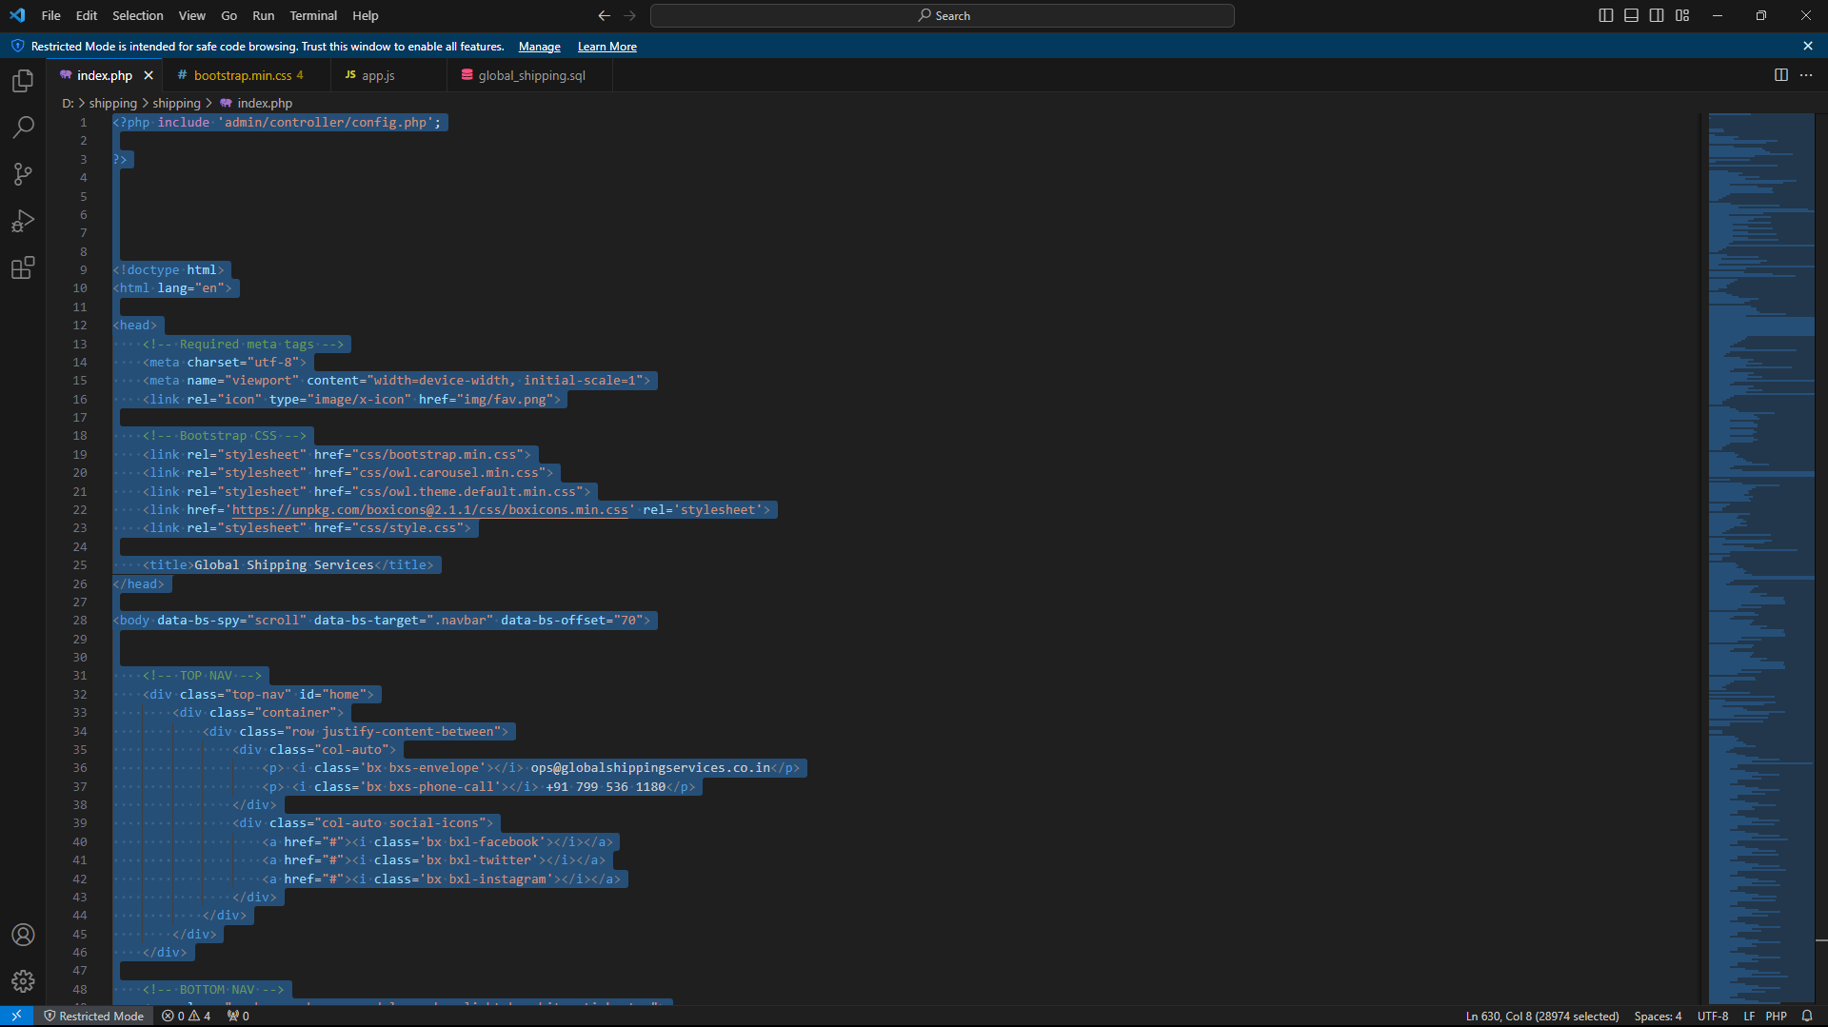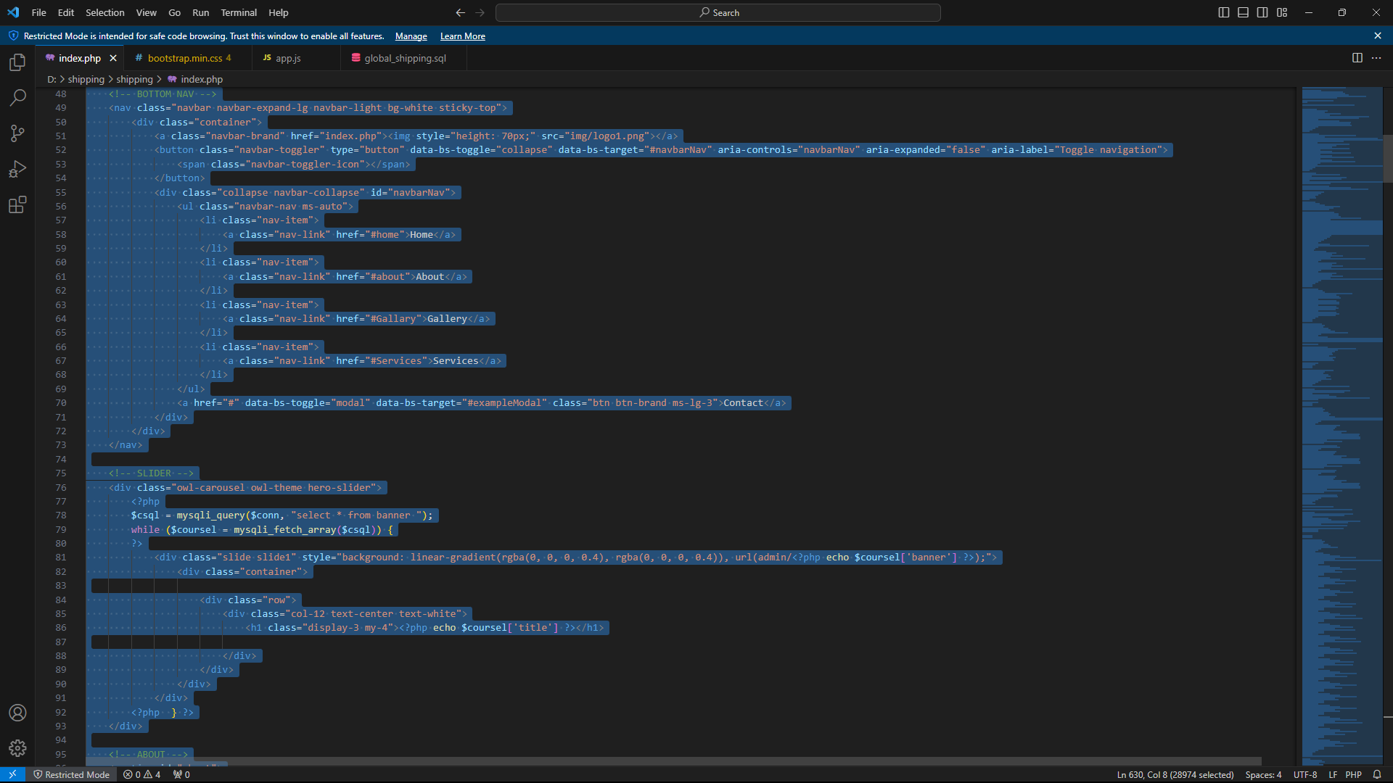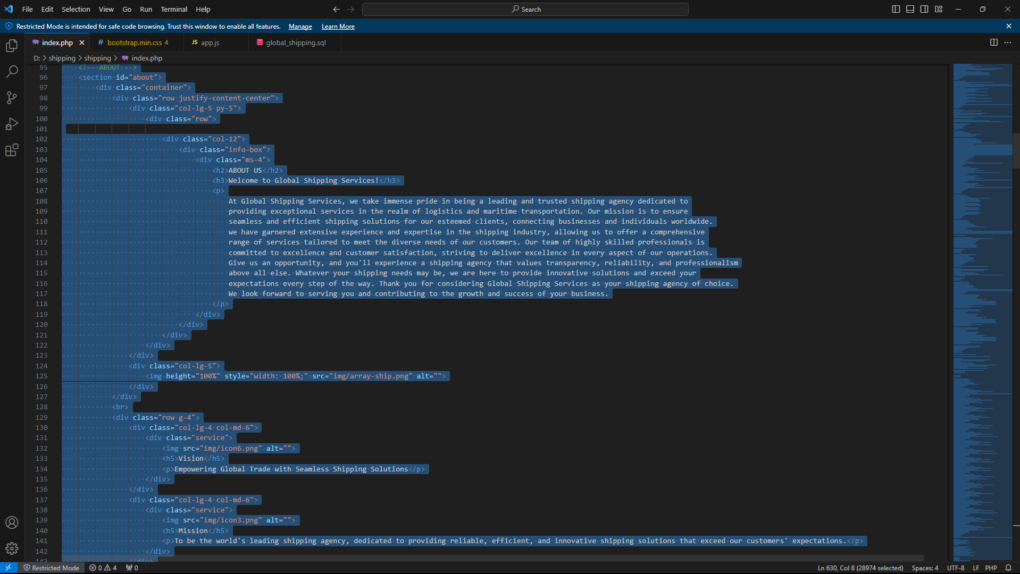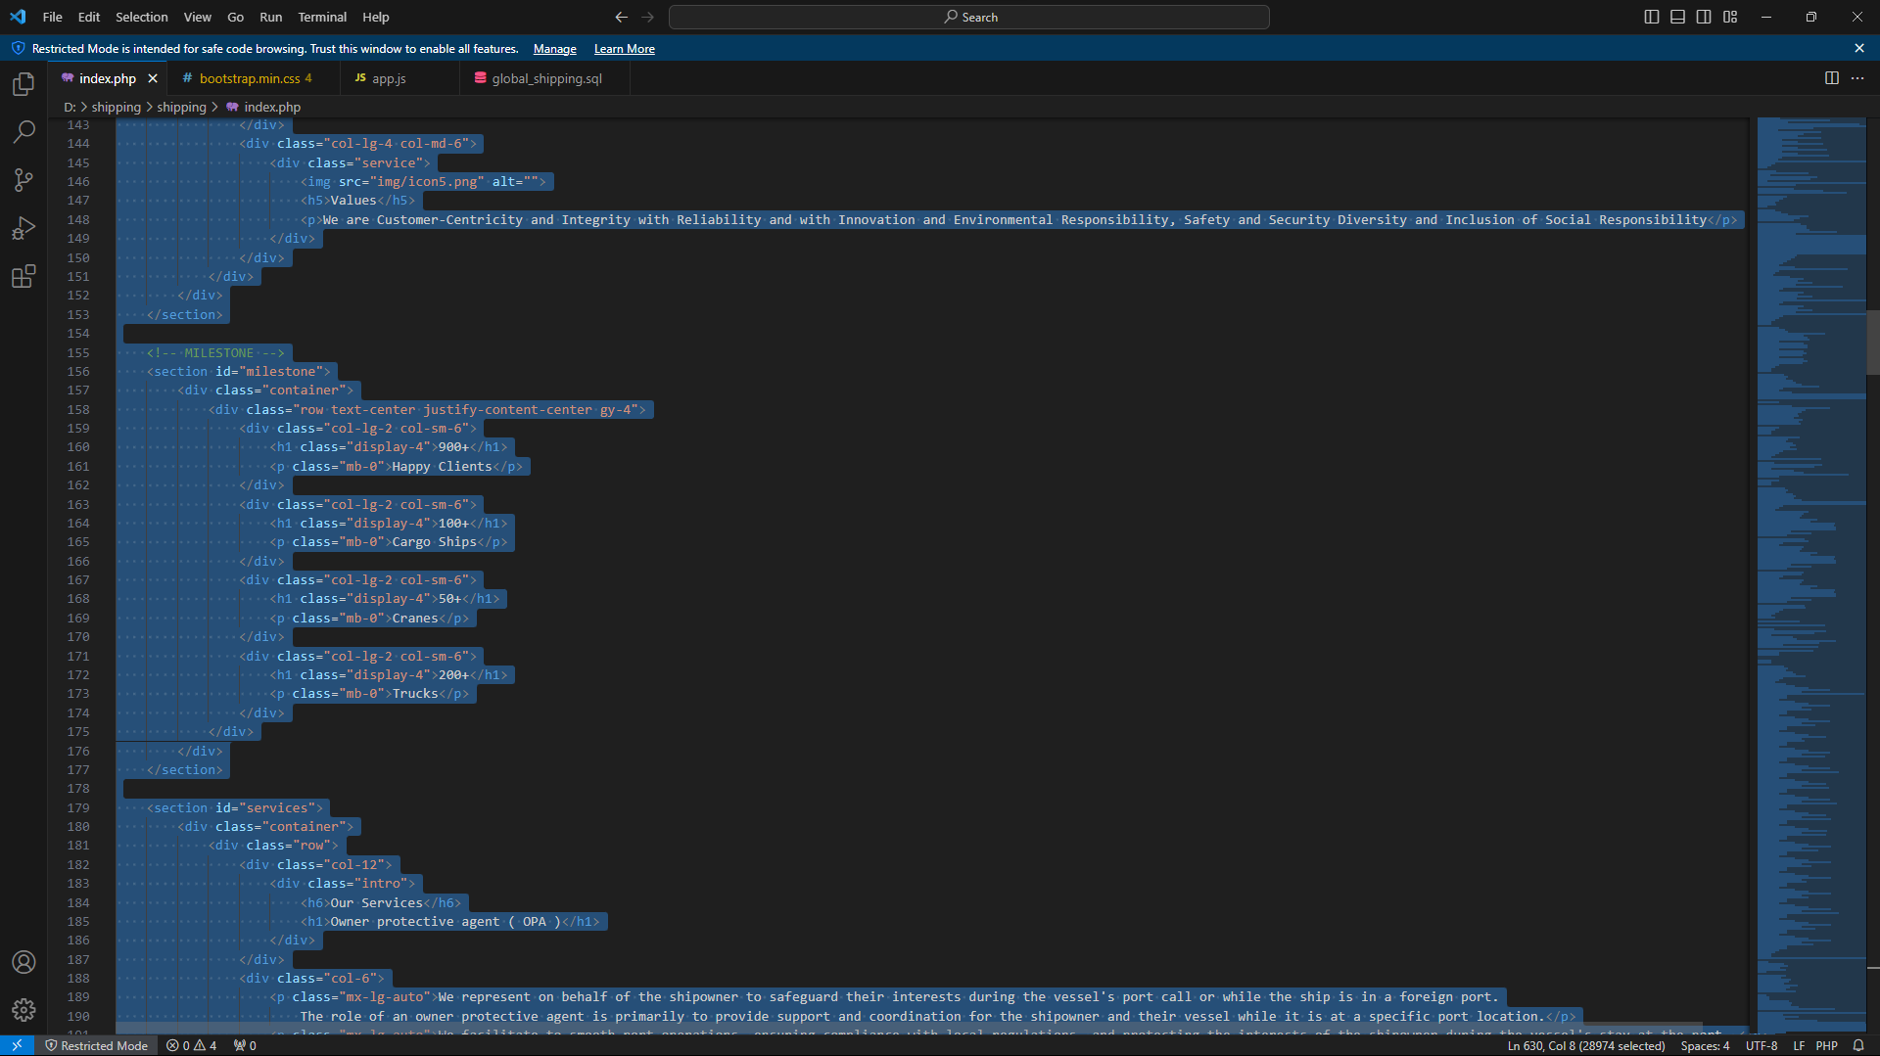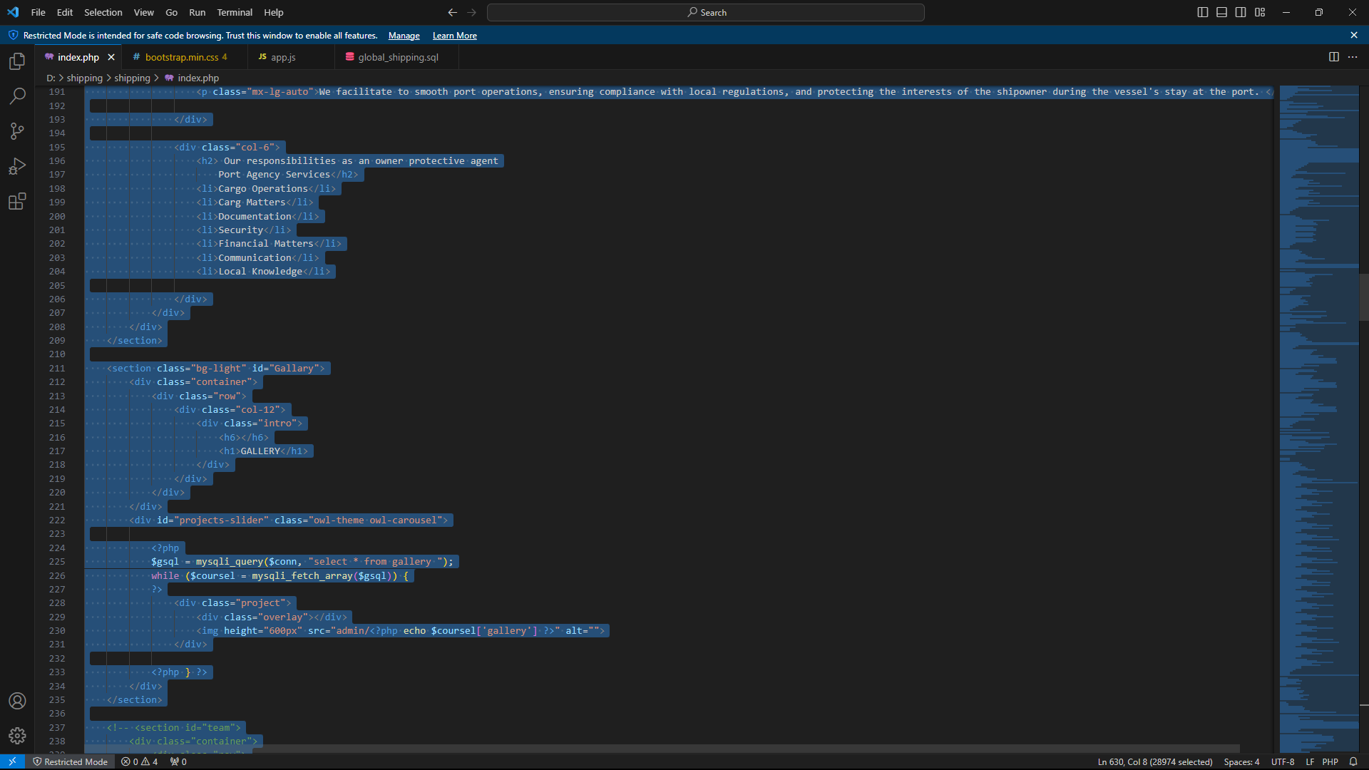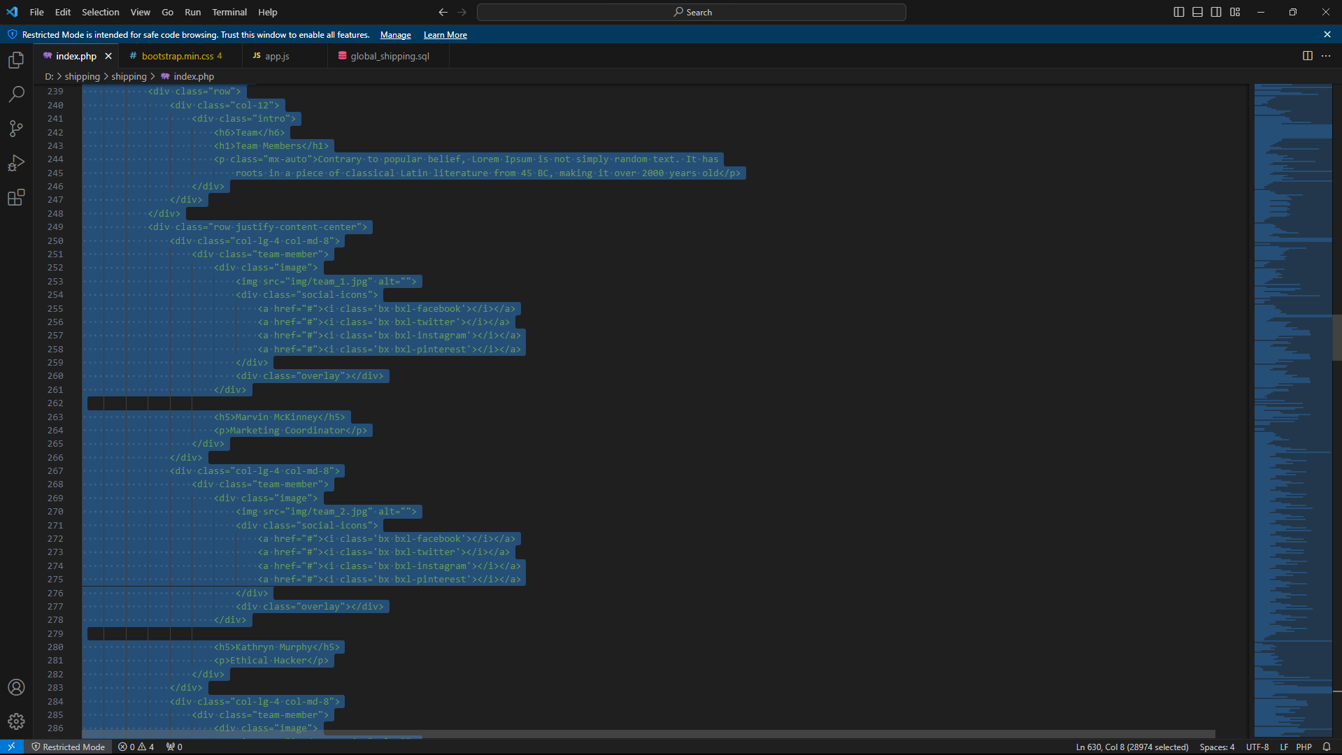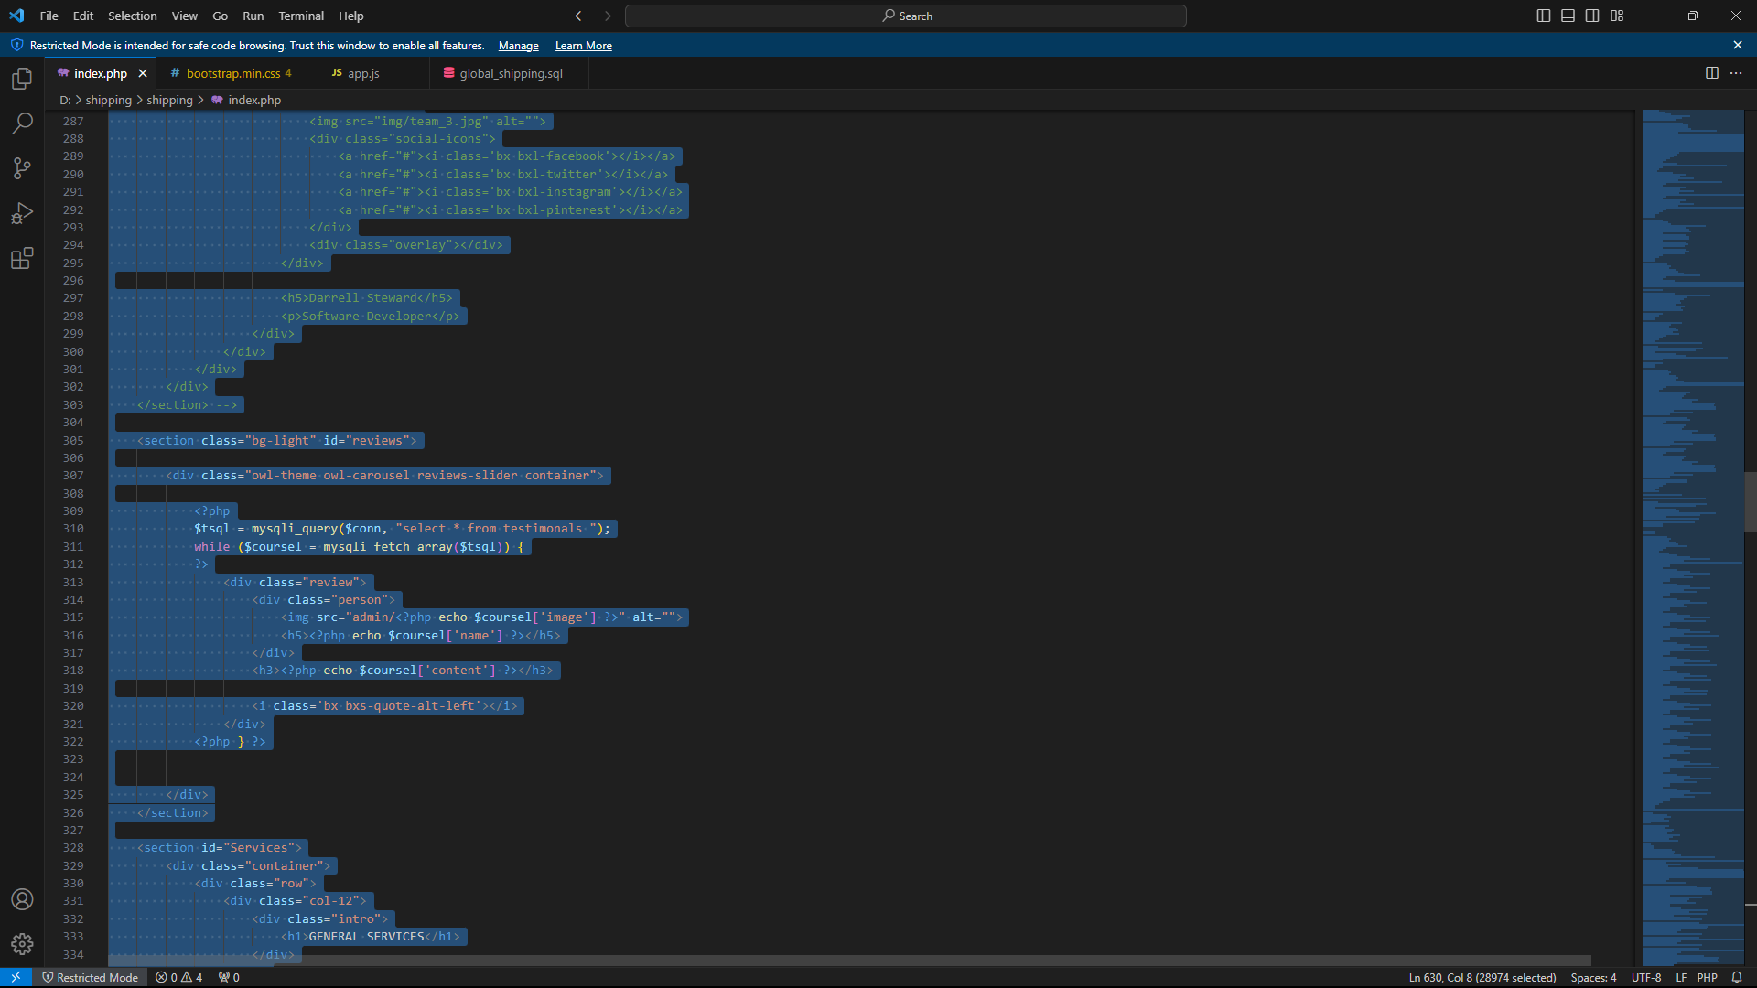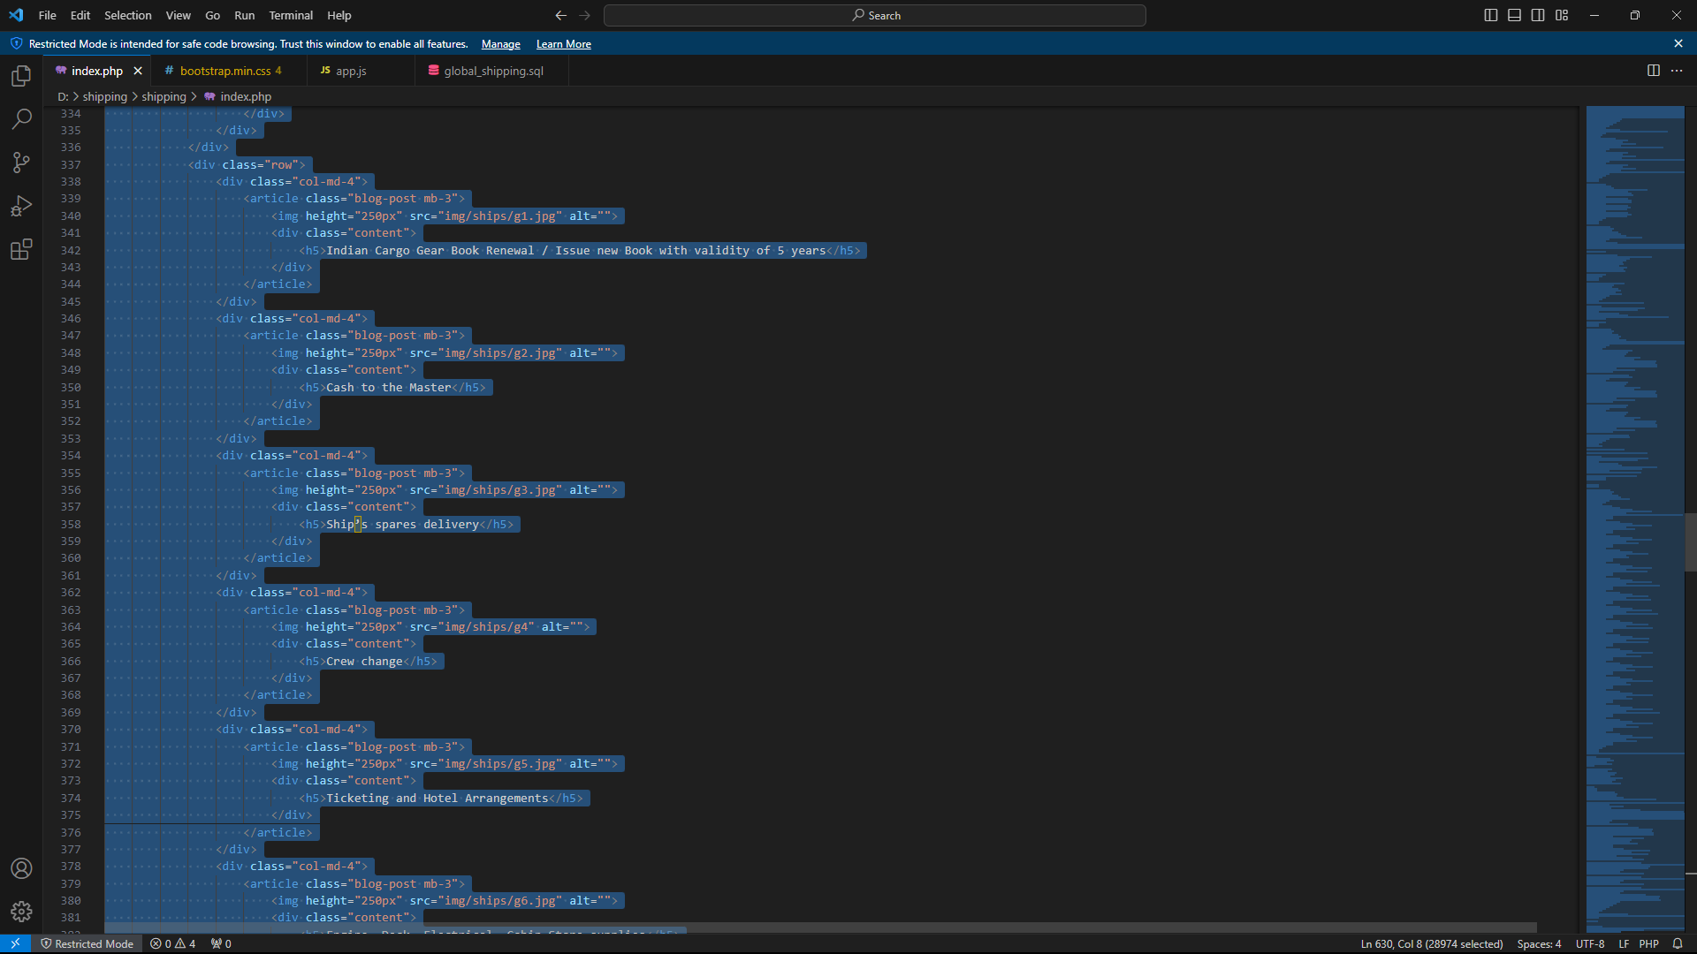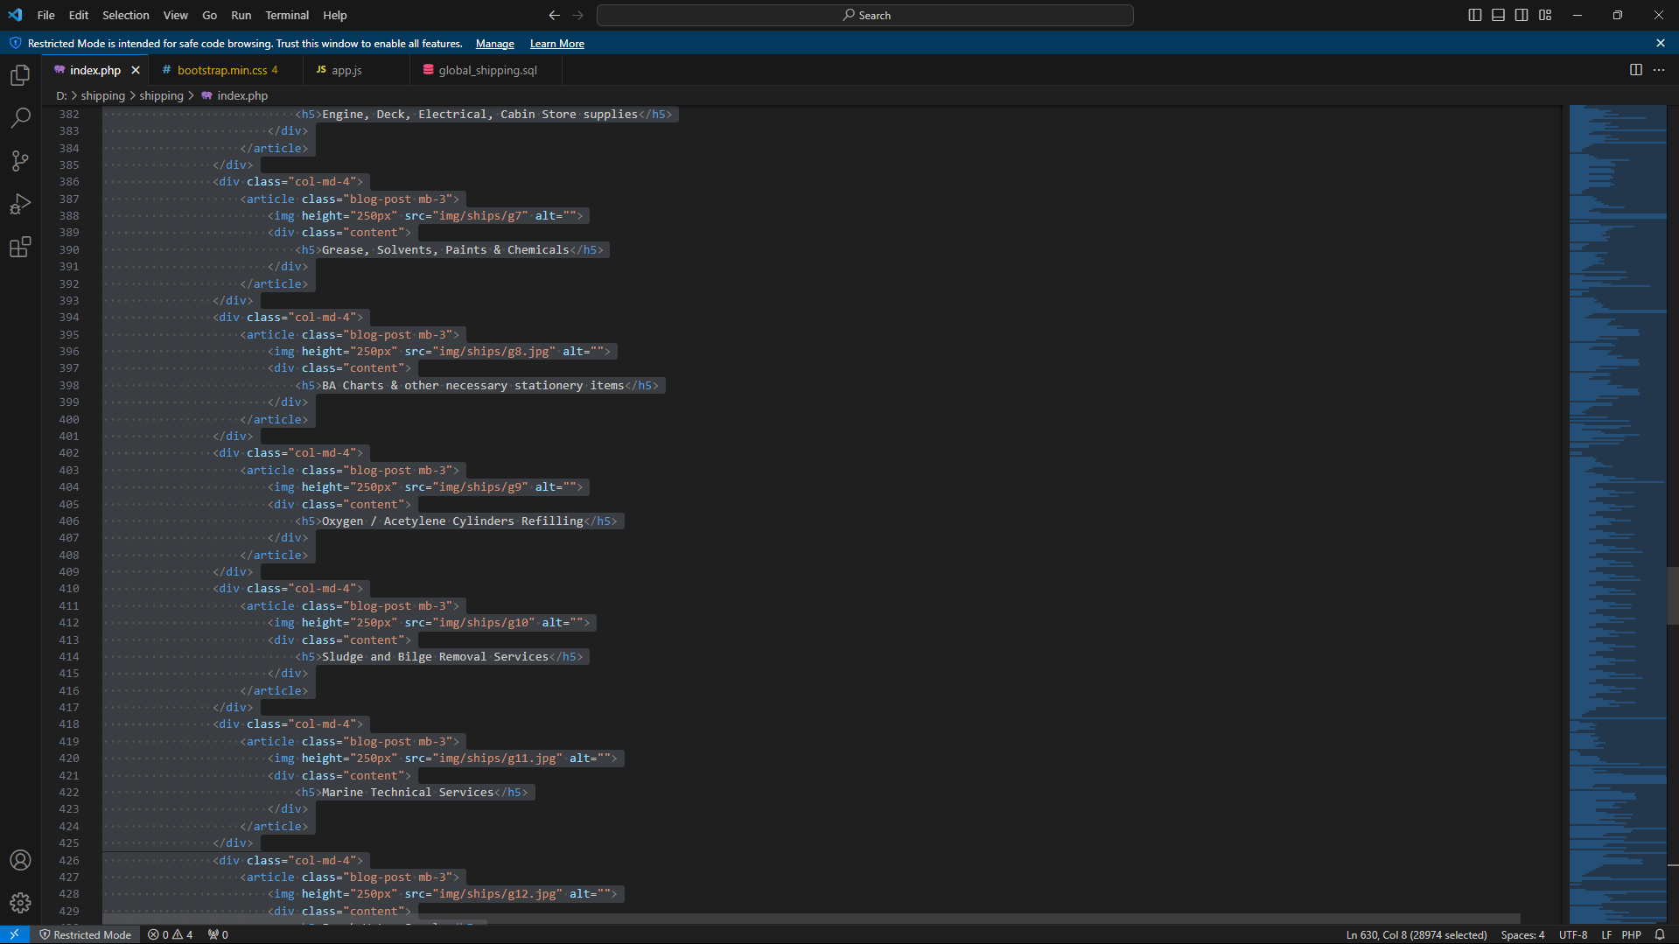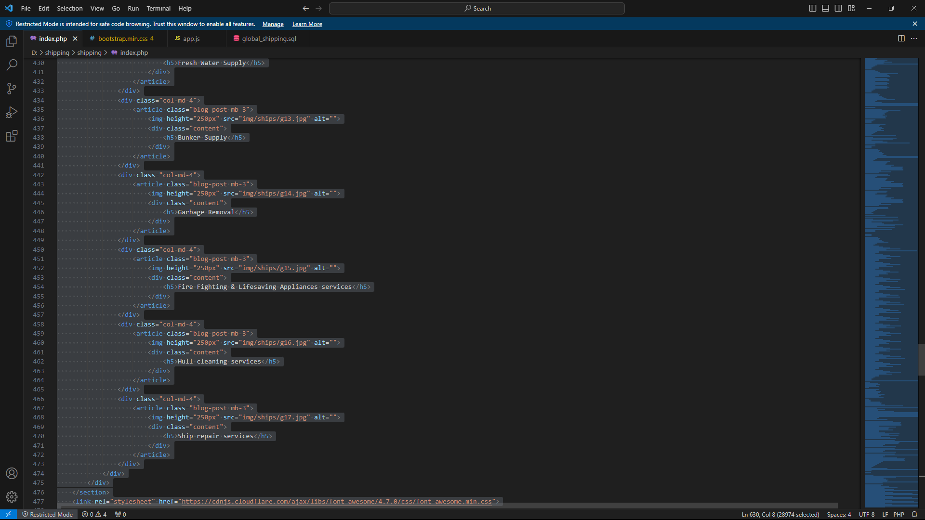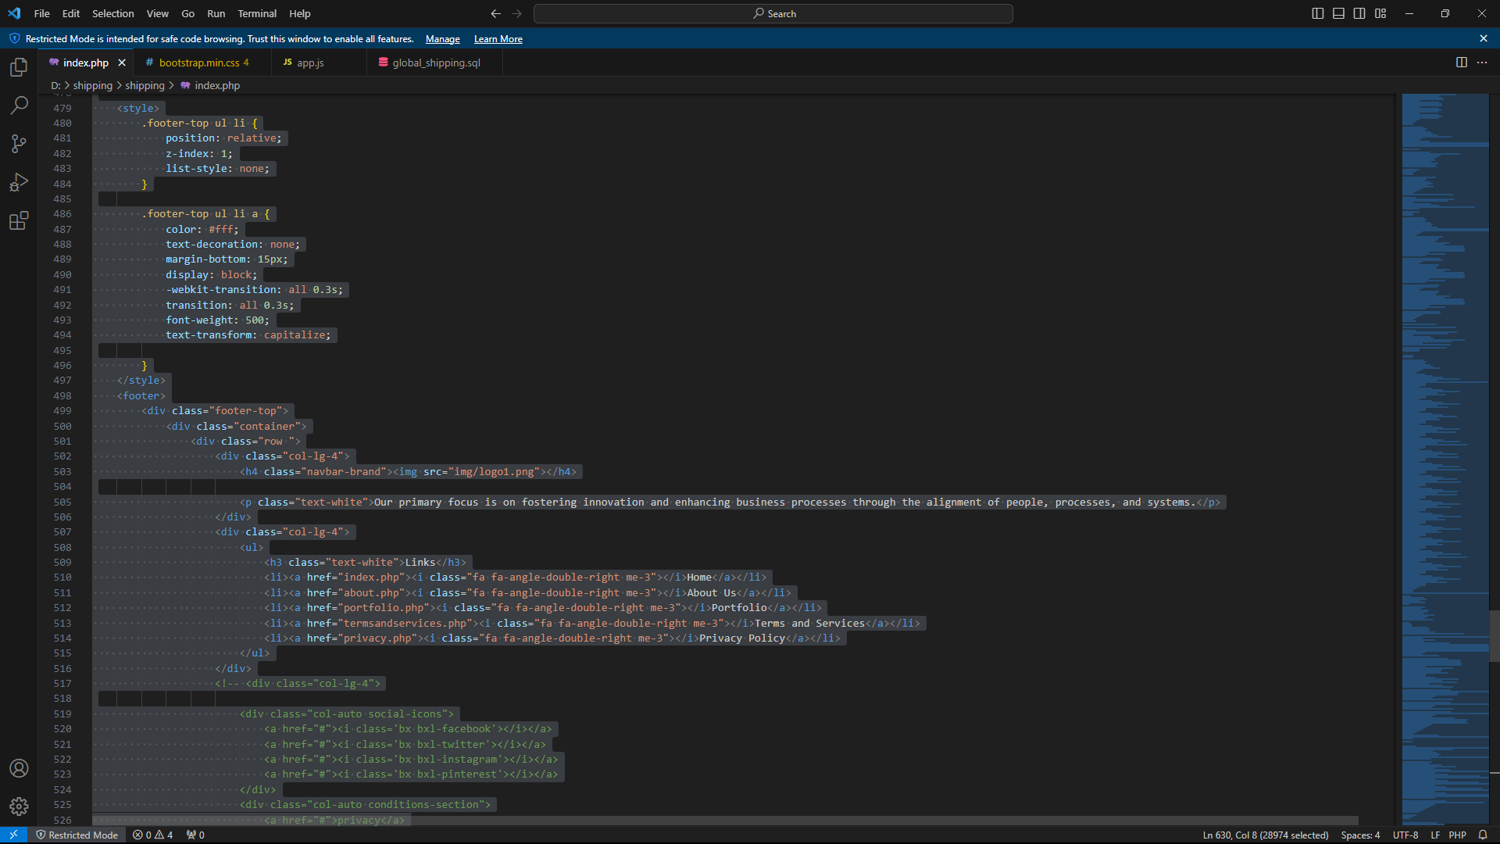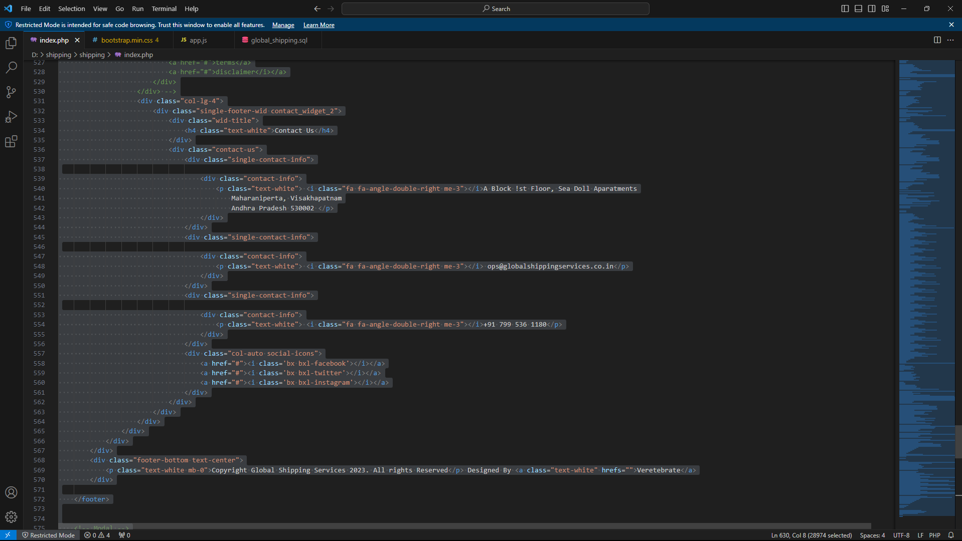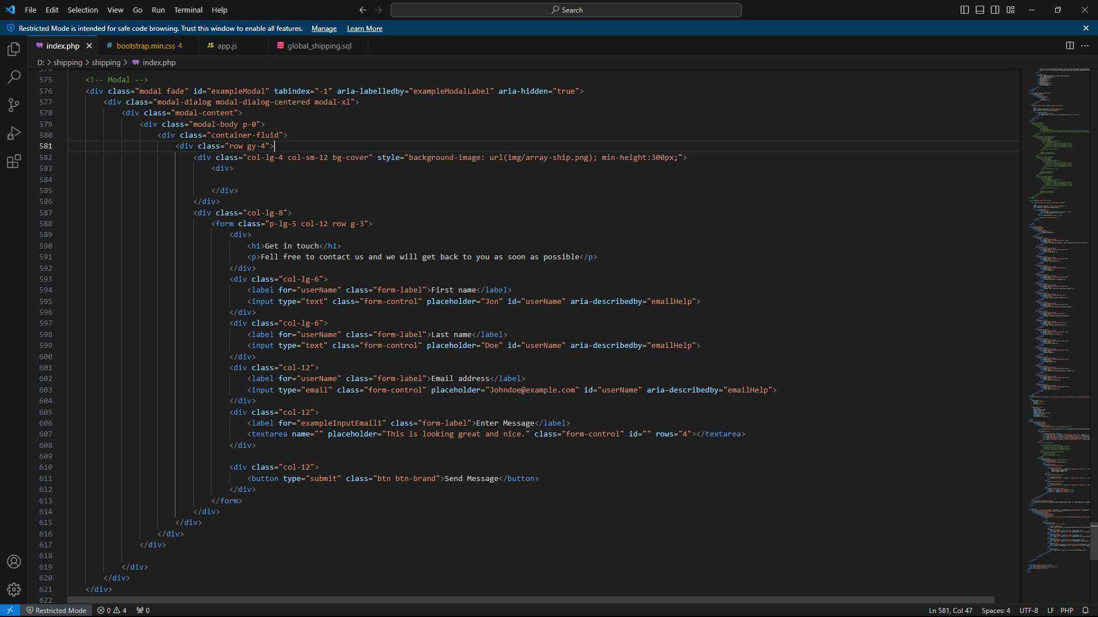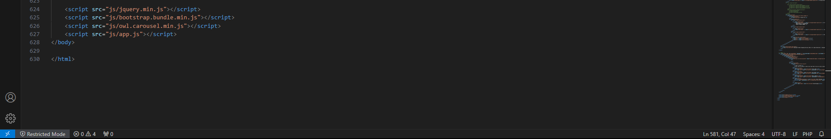

**SQL CODE:**

-- phpMyAdmin SQL Dump

-- version 4.9.11

-- https://www.phpmyadmin.net/

--

-- Host: localhost:3306

-- Generation Time: Oct 17, 2023 at 03:21 AM

-- Server version: 10.6.14-MariaDB-cll-lve

-- PHP Version: 7.4.33

SET SQL_MODE = "NO_AUTO_VALUE_ON_ZERO";

SET AUTOCOMMIT = 0;

START TRANSACTION;

SET time_zone = "+00:00";

/*!40101 SET @OLD_CHARACTER_SET_CLIENT=@@CHARACTER_SET_CLIENT */;

/*!40101 SET @OLD_CHARACTER_SET_RESULTS=@@CHARACTER_SET_RESULTS */;

/*!40101 SET @OLD_COLLATION_CONNECTION=@@COLLATION_CONNECTION */;

/*!40101 SET NAMES utf8mb4 */;

--

-- Database: `global_shipping`

--

-- --------------------------------------------------------

--

-- Table structure for table `admin`

--

CREATE TABLE `admin` (

`id` int(11) NOT NULL,

`email` varchar(200) NOT NULL,

`password` varchar(200) NOT NULL,

`role` varchar(20) NOT NULL,

`created_at` datetime NOT NULL DEFAULT current_timestamp() ON UPDATE current_timestamp()

) ENGINE=InnoDB DEFAULT CHARSET=utf8mb4 COLLATE=utf8mb4_general_ci;

--

-- Dumping data for table `admin`

--

INSERT INTO `admin` (`id`, `email`, `password`, `role`, `created_at`) VALUES

(1, 'admin@gmail.com', 'verte@2023', '1', '2023-08-08 16:48:52');

-- --------------------------------------------------------

--

-- Table structure for table `banner`

--

CREATE TABLE `banner` (

`banner_id` int(11) NOT NULL,

`title` varchar(200) NOT NULL,

`banner` varchar(200) NOT NULL,

`created_at` datetime NOT NULL DEFAULT current_timestamp() ON UPDATE current_timestamp()

) ENGINE=InnoDB DEFAULT CHARSET=utf8mb4 COLLATE=utf8mb4_general_ci;

--

-- Dumping data for table `banner`

--

INSERT INTO `banner` (`banner_id`, `title`, `banner`, `created_at`) VALUES

(12, 'shipping Services', 'uploads/banner_1696835486.jpg', '2023-10-09 15:31:02'),

(13, 'beautiful ship', 'uploads/banner_1696841610.jpg', '2023-10-09 15:30:44');

-- --------------------------------------------------------

--

-- Table structure for table `gallery`

--

CREATE TABLE `gallery` (

`gallery_id` int(11) NOT NULL,

`gallery` varchar(200) NOT NULL,

`created_at` datetime NOT NULL DEFAULT current_timestamp() ON UPDATE current_timestamp()

) ENGINE=InnoDB DEFAULT CHARSET=utf8mb4 COLLATE=utf8mb4_general_ci;

--

-- Dumping data for table `gallery`

--

INSERT INTO `gallery` (`gallery_id`, `gallery`, `created_at`) VALUES

(5, 'uploads/gallery_1696839319.jpg', '2023-10-09 13:45:19'),

(6, 'uploads/gallery_1696839331.jpg', '2023-10-09 13:45:31'),

(7, 'uploads/gallery_1696839340.jfif', '2023-10-09 13:45:40'),

(8, 'uploads/gallery_1696839354.jpg', '2023-10-09 13:45:54');

-- --------------------------------------------------------

--

-- Table structure for table `testimonals`

--

CREATE TABLE `testimonals` (

`test_id` int(11) NOT NULL,

`name` varchar(50) NOT NULL,

`image` varchar(200) NOT NULL,

`content` text NOT NULL,

`created_at` datetime NOT NULL DEFAULT current_timestamp() ON UPDATE current_timestamp()

) ENGINE=InnoDB DEFAULT CHARSET=utf8mb4 COLLATE=utf8mb4_general_ci;

--

-- Dumping data for table `testimonals`

--

INSERT INTO `testimonals` (`test_id`, `name`, `image`, `content`, `created_at`) VALUES

(5, 'KL Rahul', 'uploads/testimonals_1696839654.jpg', 'Fast and reliable shipping, always on time!\r\n', '2023-10-09 14:50:56'),

(6, 'Tim Cook', 'uploads/testimonals_1696839795.jpg', 'Exceptional shipping service, top-notch quality', '2023-10-09 14:50:35'),

(7, 'Starc', 'uploads/testimonals_1696839864.jpg', 'Flawless shipping, A+ service.\r\n', '2023-10-09 14:50:13');

--

-- Indexes for dumped tables

--

--

-- Indexes for table `admin`

--

ALTER TABLE `admin`

ADD PRIMARY KEY (`id`);

--

-- Indexes for table `banner`

--

ALTER TABLE `banner`

ADD PRIMARY KEY (`banner_id`);

--

-- Indexes for table `gallery`

--

ALTER TABLE `gallery`

ADD PRIMARY KEY (`gallery_id`);

--

-- Indexes for table `testimonals`

--

ALTER TABLE `testimonals`

ADD PRIMARY KEY (`test_id`);

--

-- AUTO_INCREMENT for dumped tables

--

--

-- AUTO_INCREMENT for table `admin`

--

ALTER TABLE `admin`

MODIFY `id` int(11) NOT NULL AUTO_INCREMENT, AUTO_INCREMENT=2;

--

-- AUTO_INCREMENT for table `banner`

--

ALTER TABLE `banner`

MODIFY `banner_id` int(11) NOT NULL AUTO_INCREMENT, AUTO_INCREMENT=14;

--

-- AUTO_INCREMENT for table `gallery`

--

ALTER TABLE `gallery`

MODIFY `gallery_id` int(11) NOT NULL AUTO_INCREMENT, AUTO_INCREMENT=9;

--

-- AUTO_INCREMENT for table `testimonals`

--

ALTER TABLE `testimonals`

MODIFY `test_id` int(11) NOT NULL AUTO_INCREMENT, AUTO_INCREMENT=8;

COMMIT;

/*!40101 SET CHARACTER_SET_CLIENT=@OLD_CHARACTER_SET_CLIENT */;

/*!40101 SET CHARACTER_SET_RESULTS=@OLD_CHARACTER_SET_RESULTS */;

/*!40101 SET COLLATION_CONNECTION=@OLD_COLLATION_CONNECTION */;

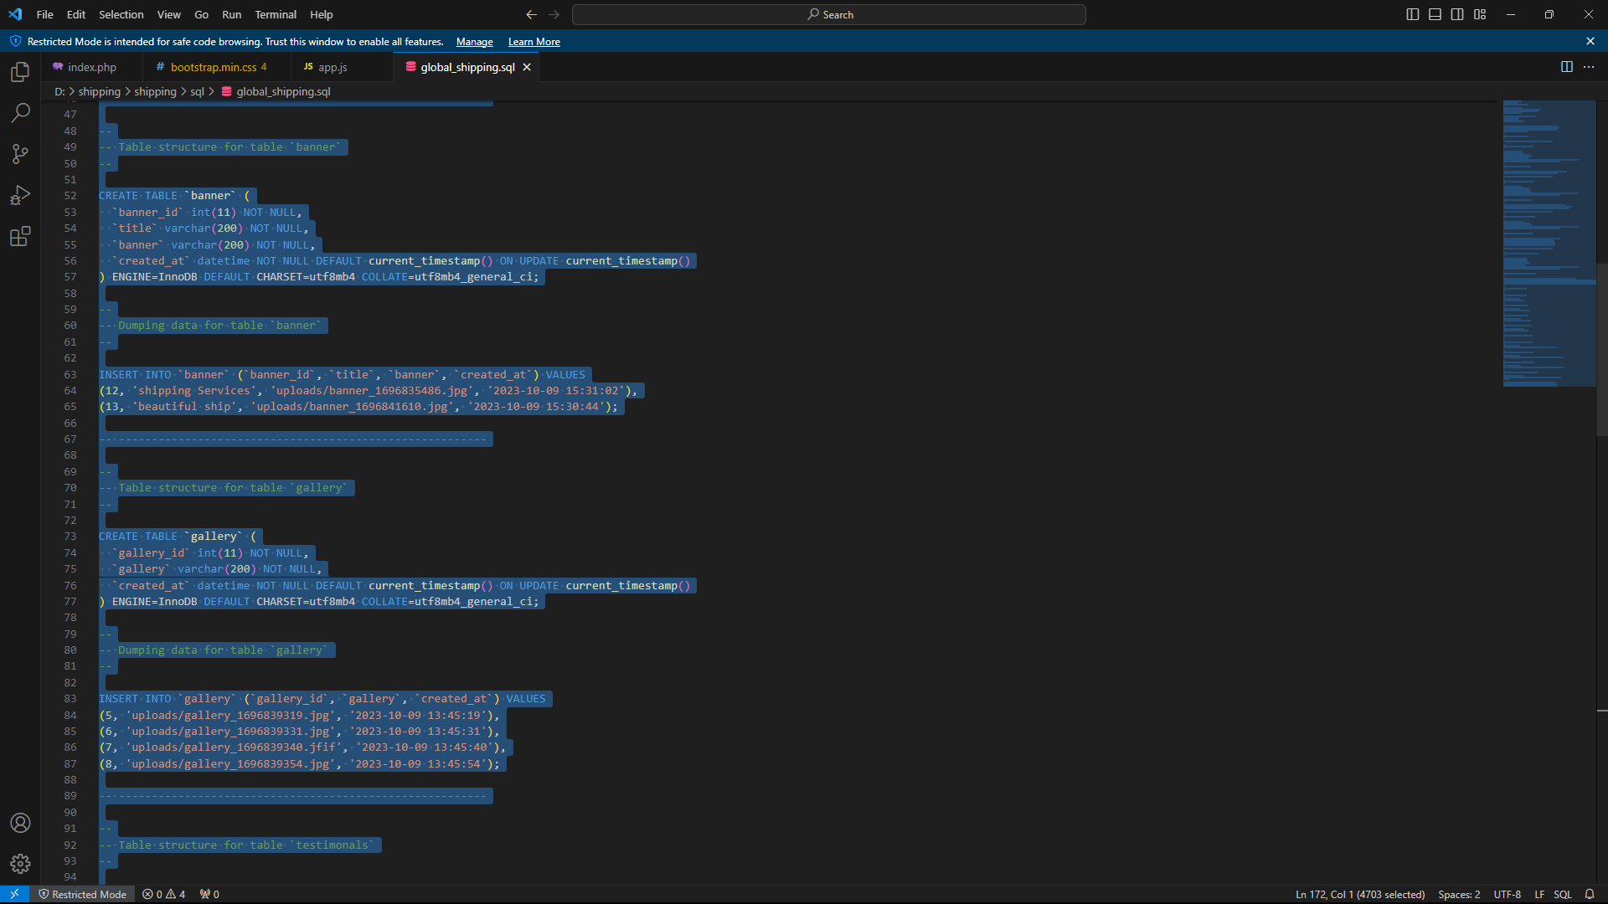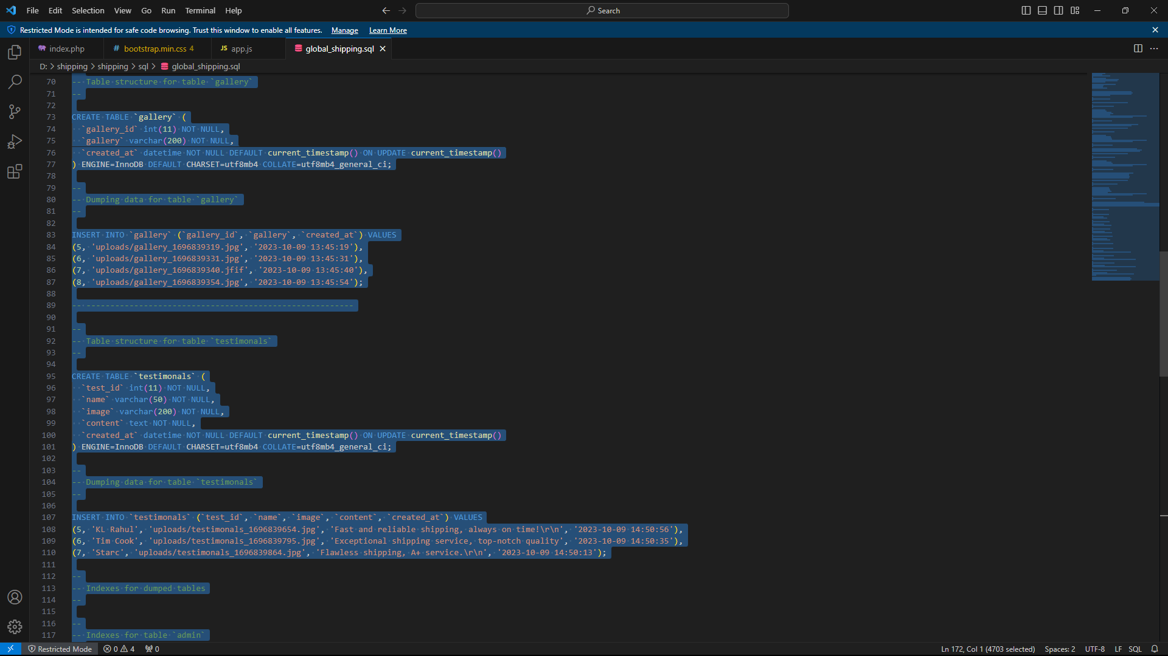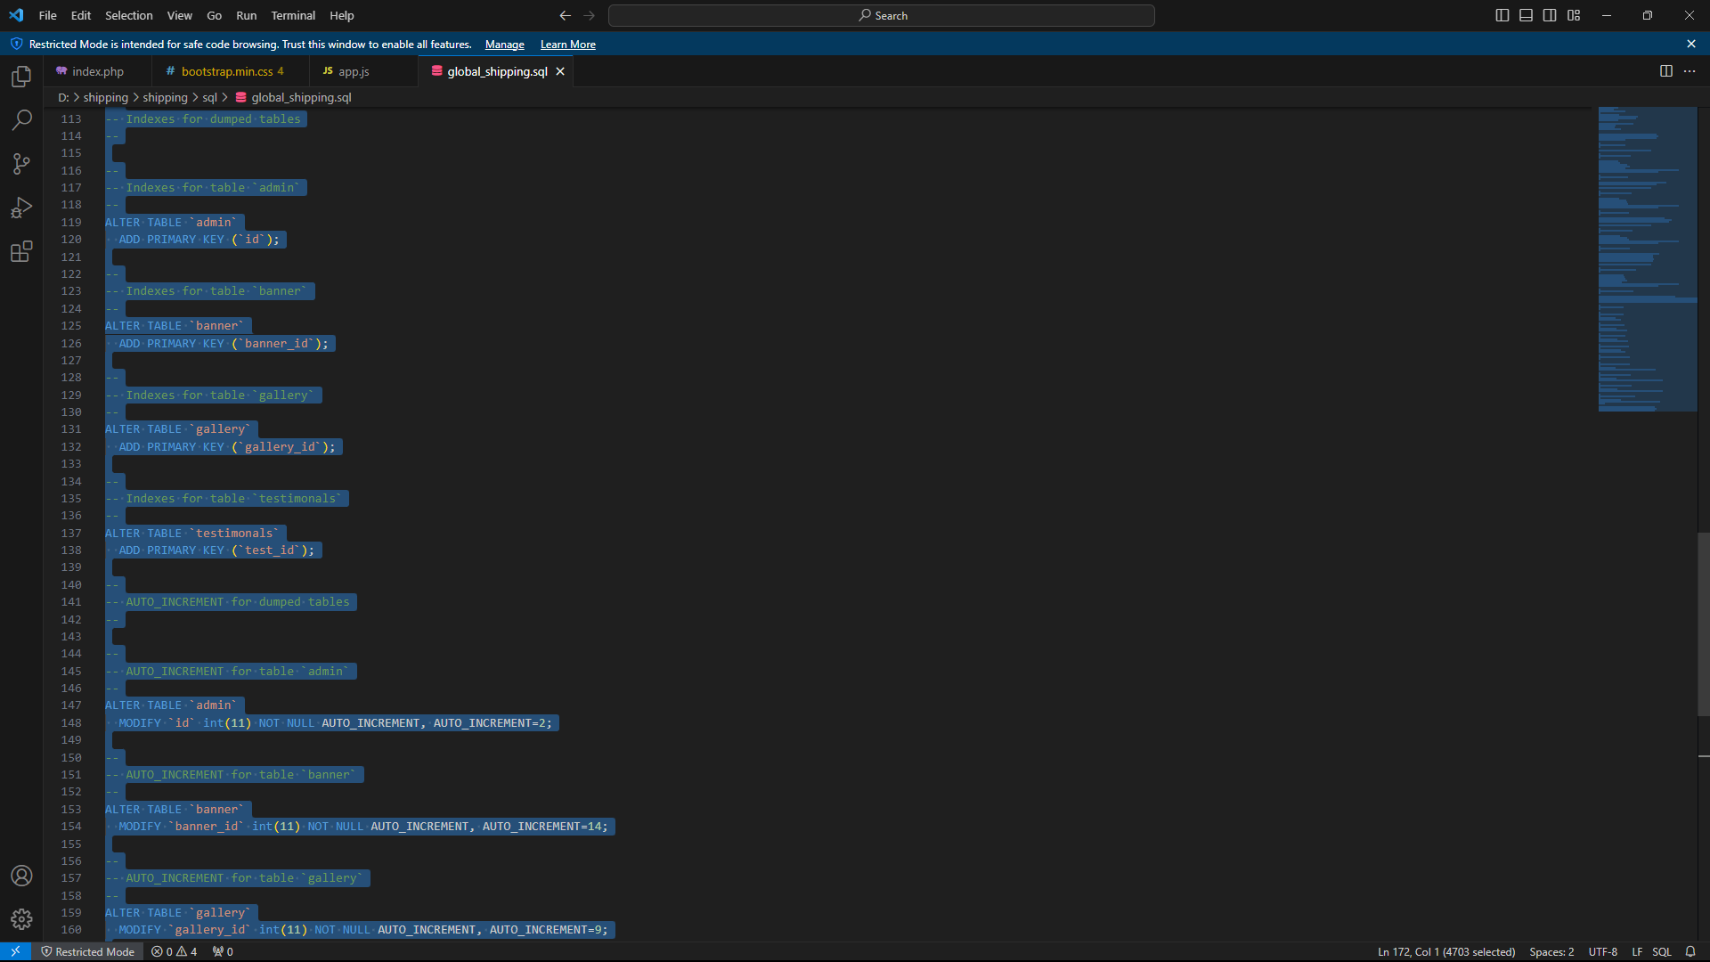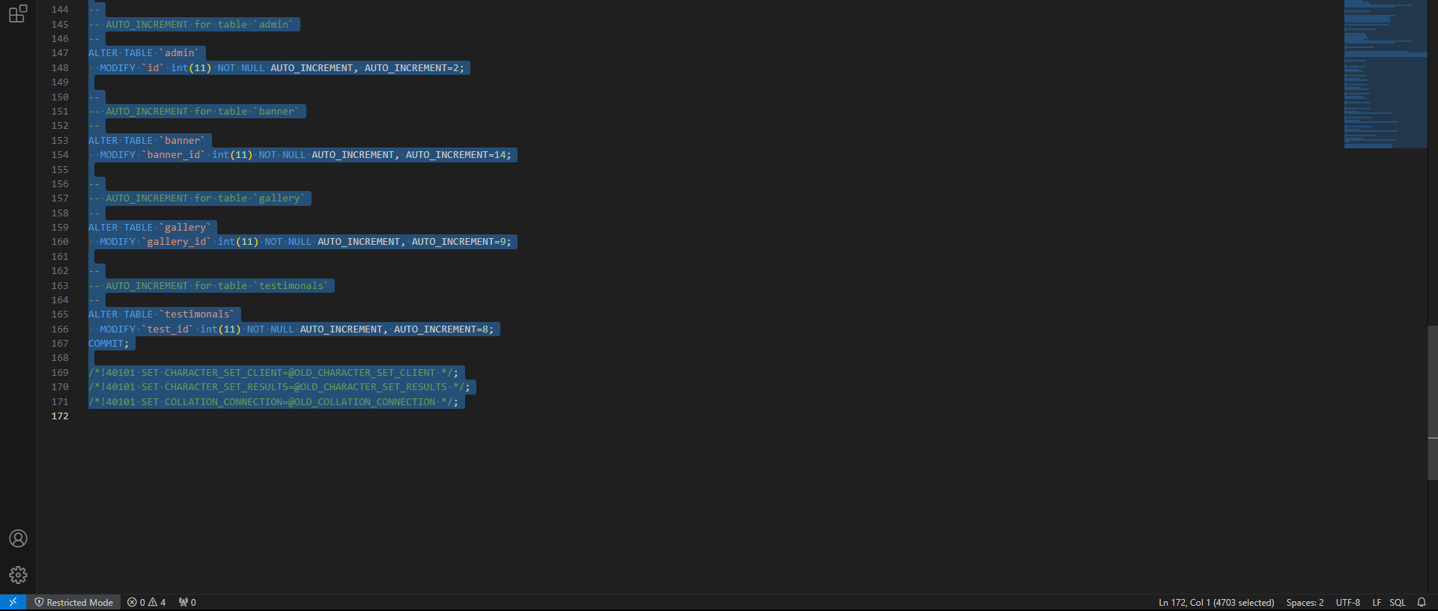

**Images:**

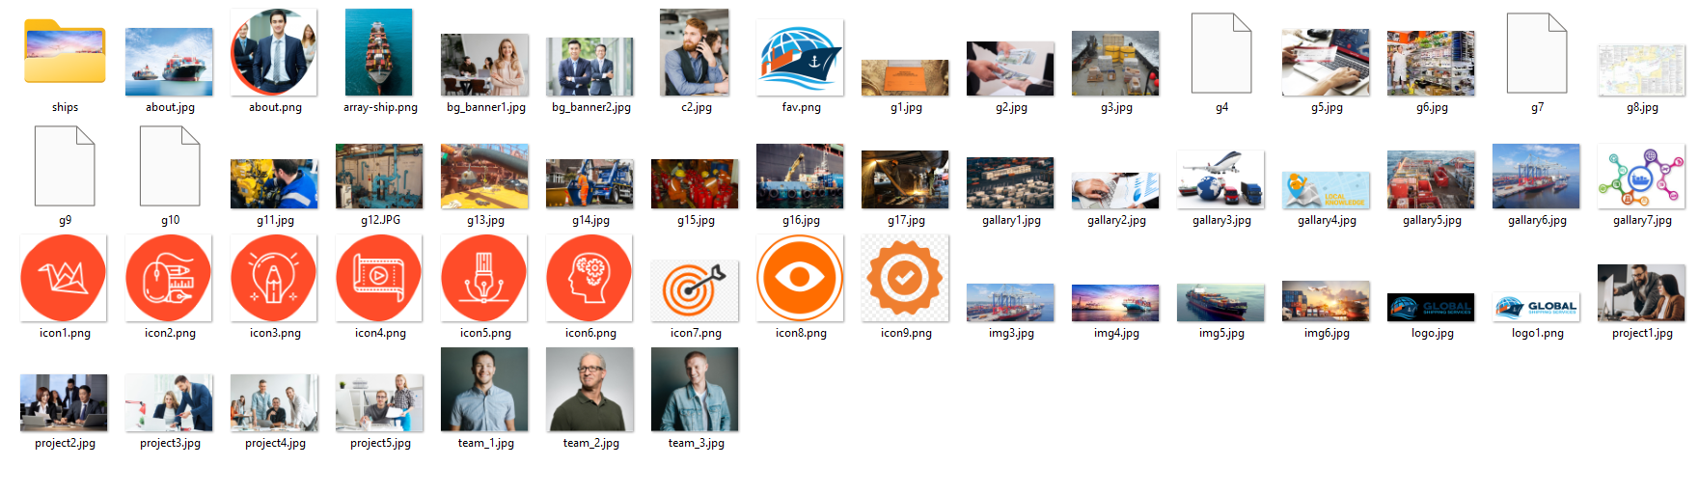

**EXECUTION & OUTPUT:**

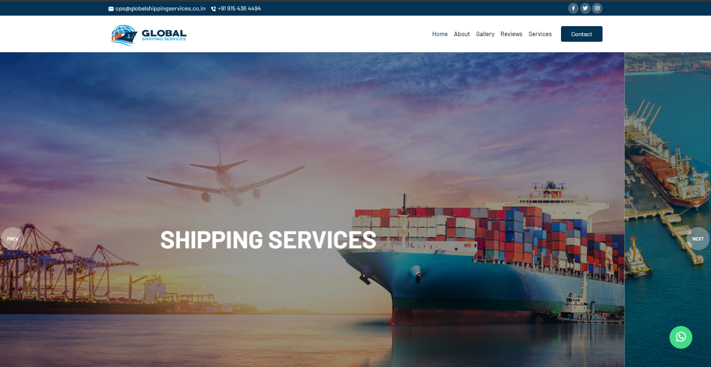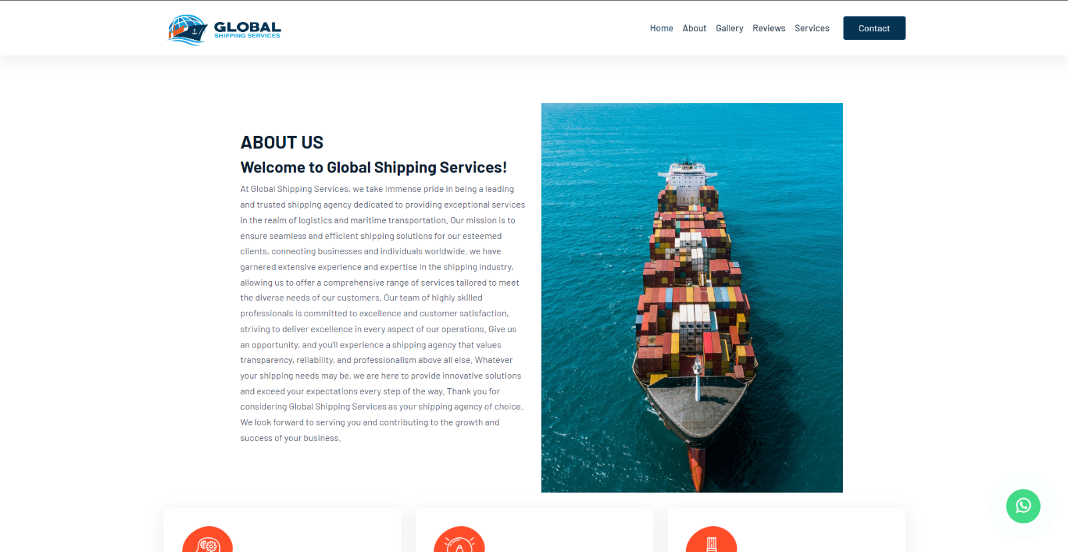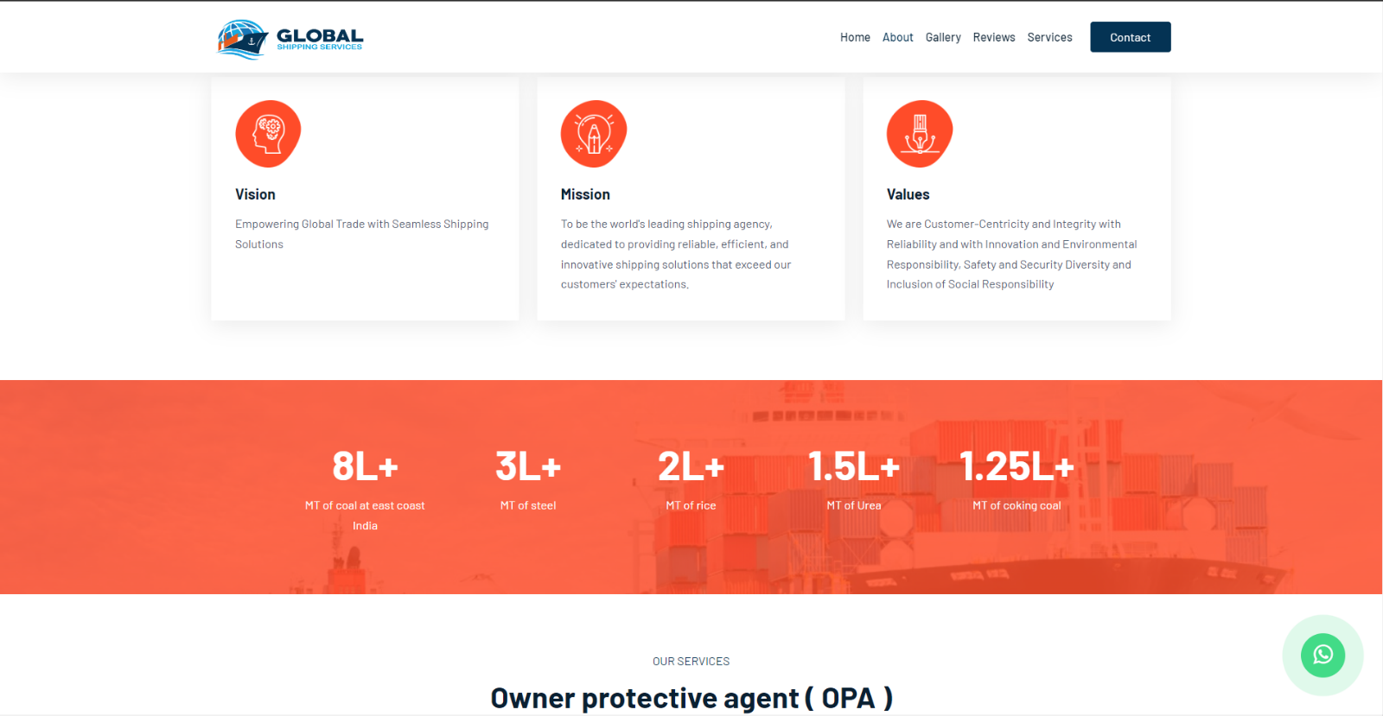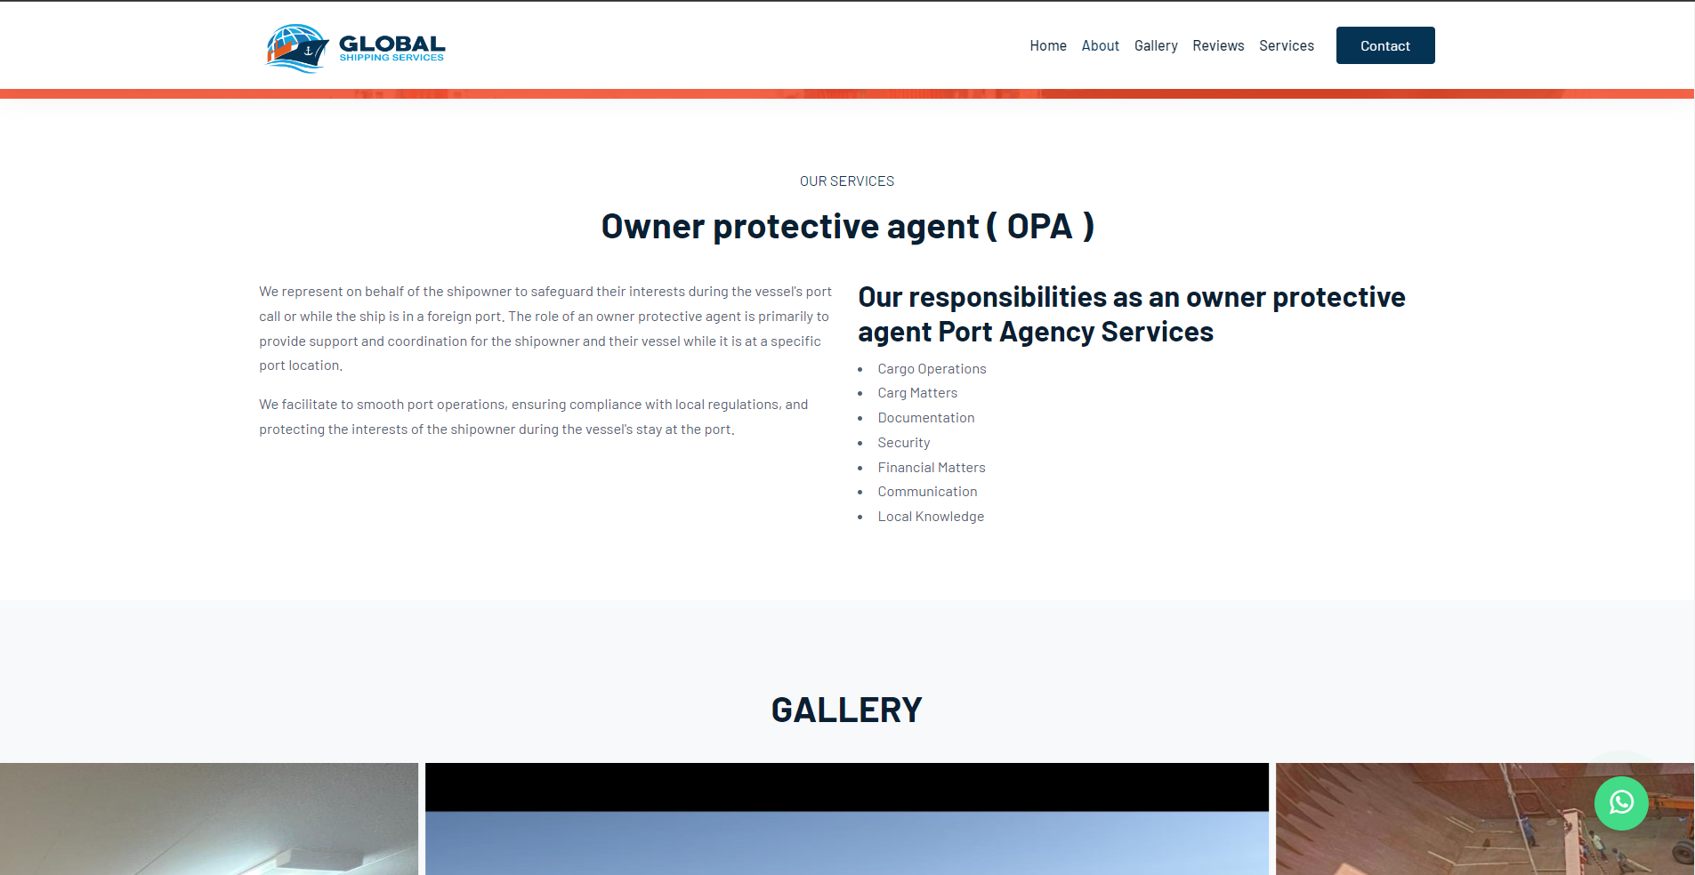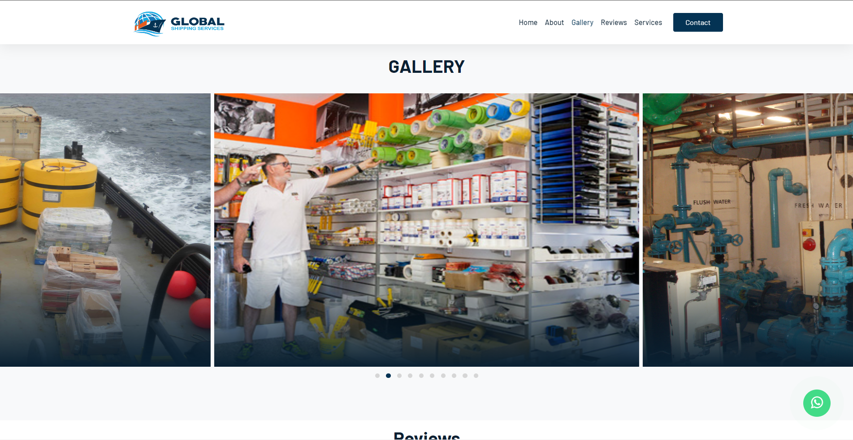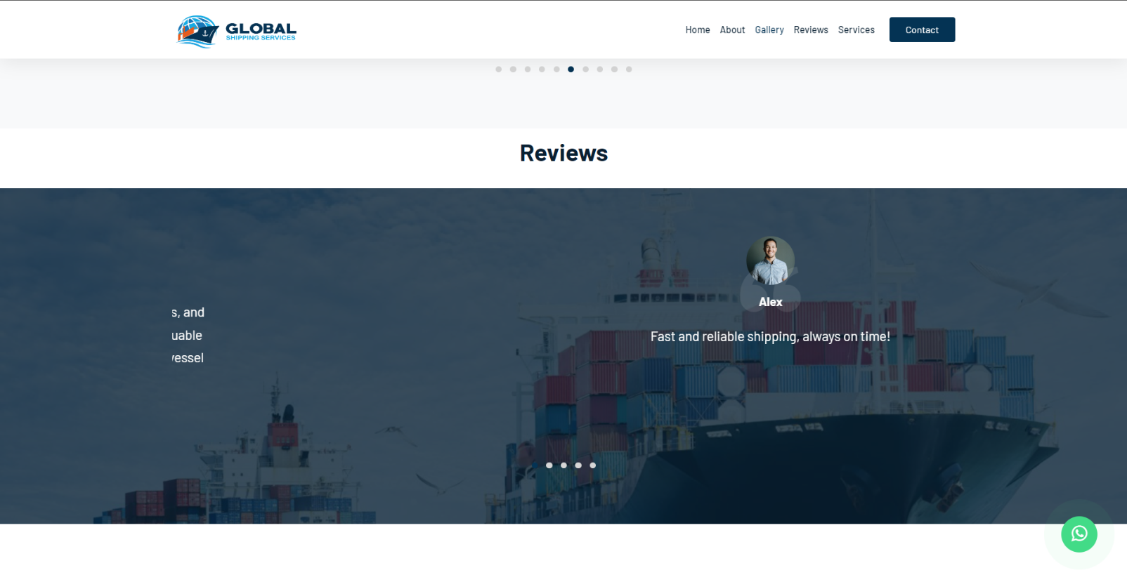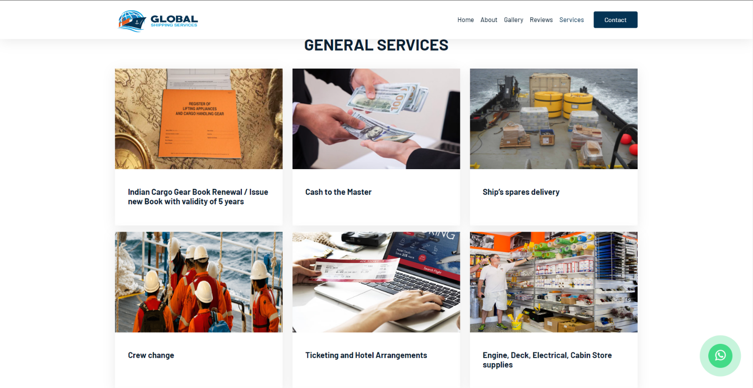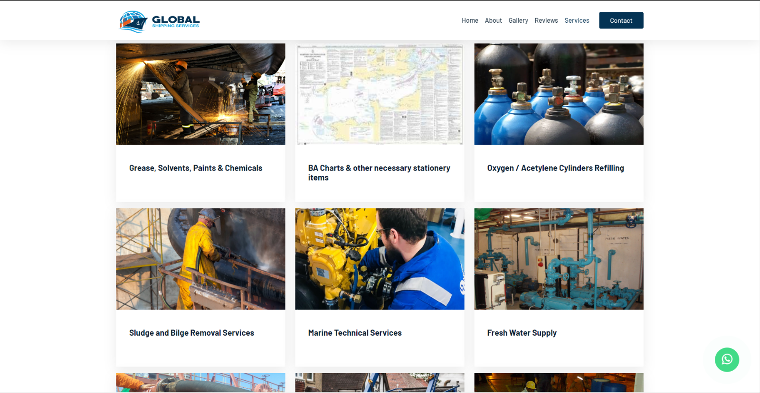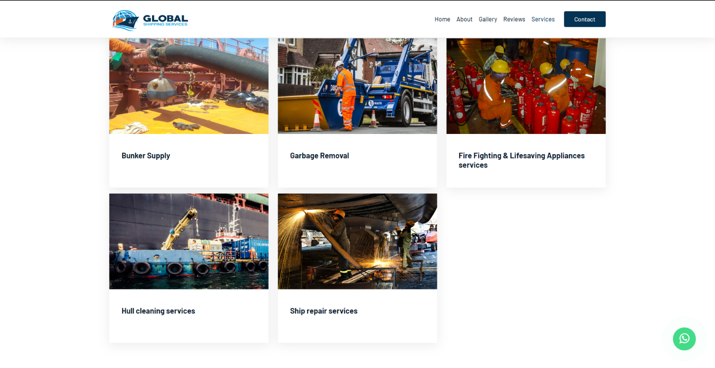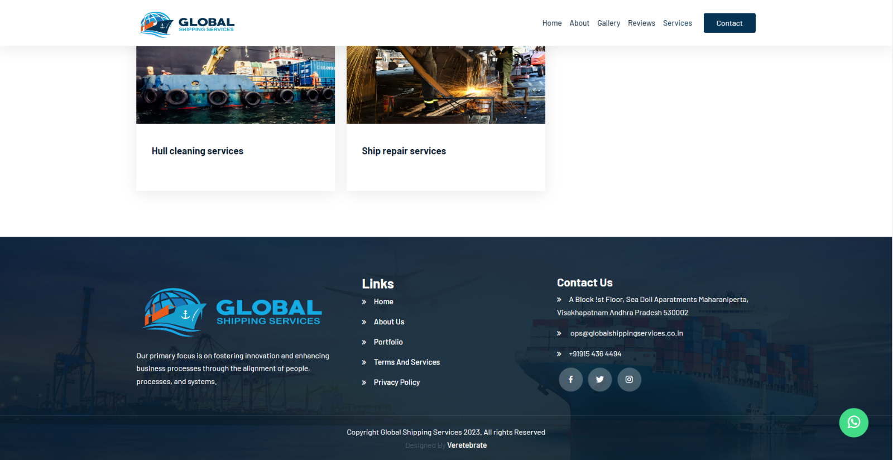

**SQL:**

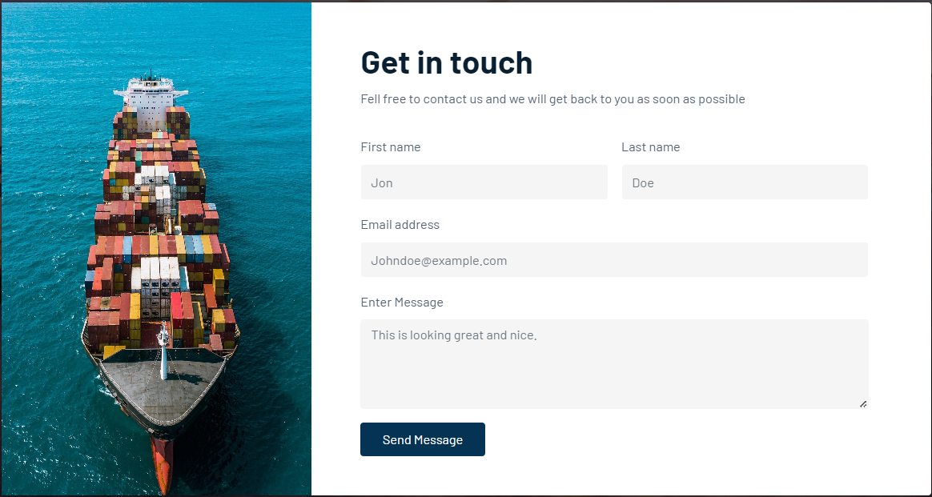

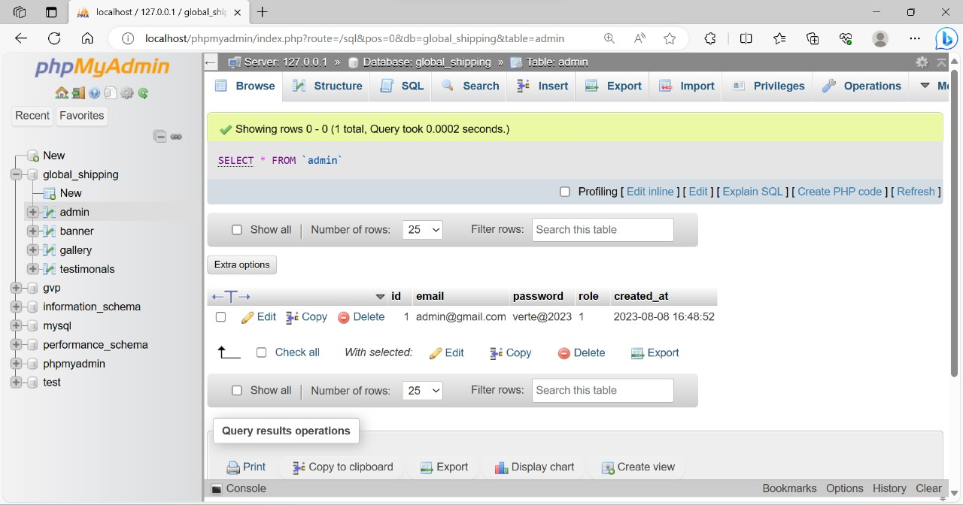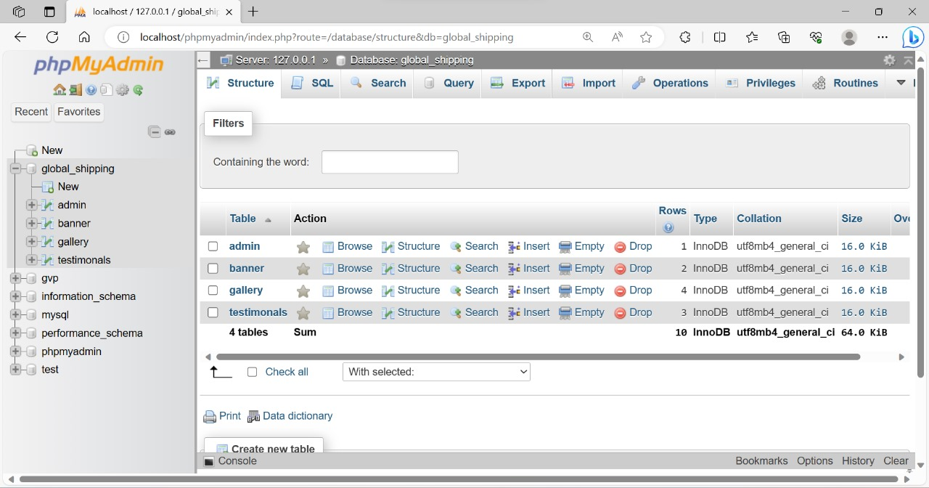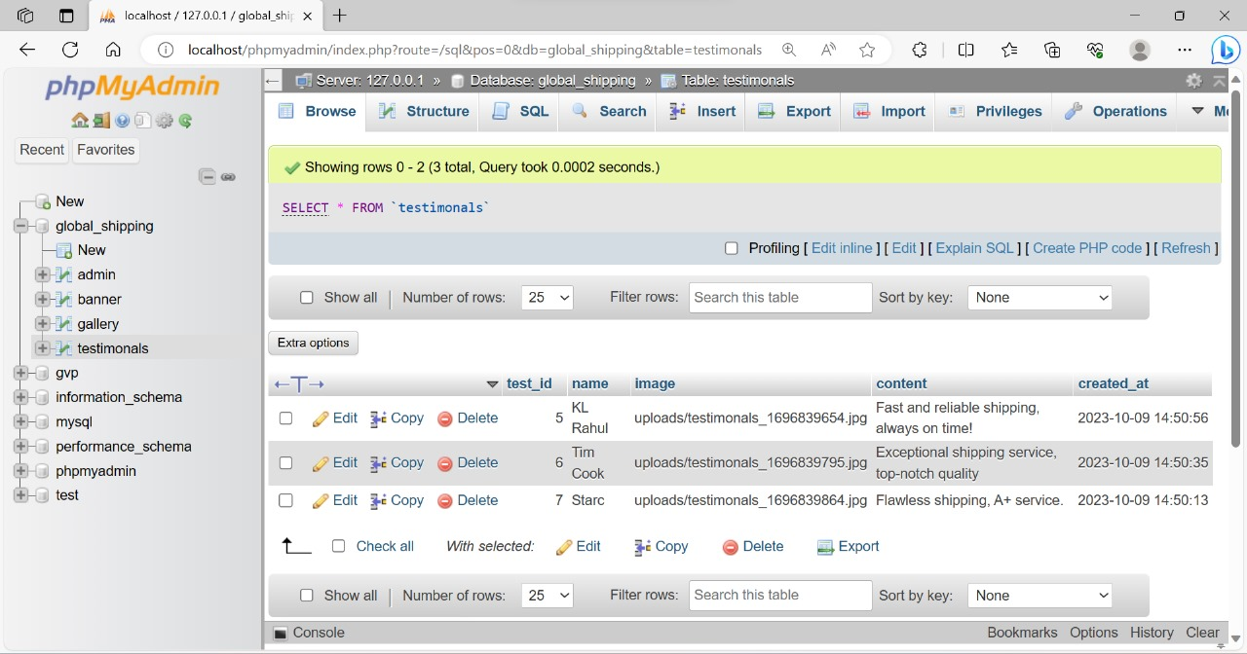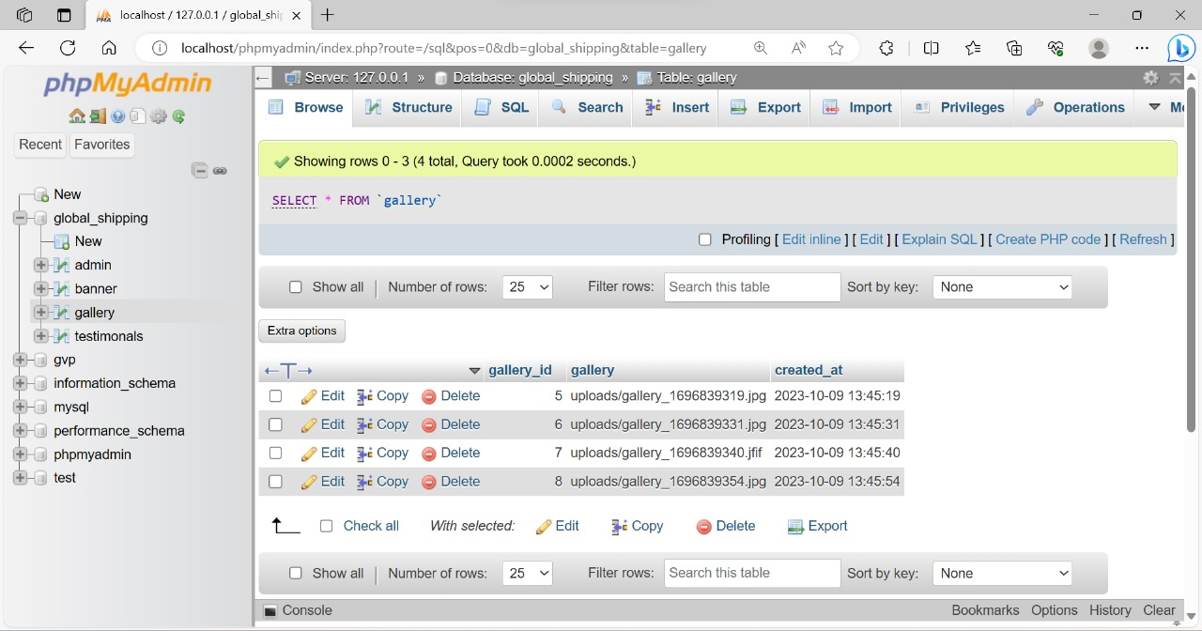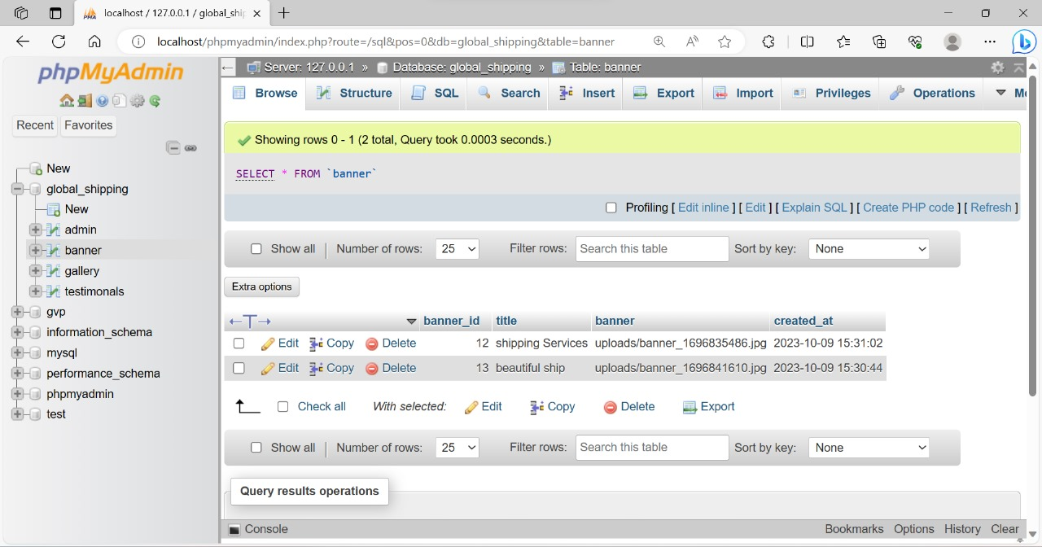

**Tools:**

**VISUAL STUDIO:**

Visual Studio is an integrated development environment (IDE) from Microsoft. It is used to develop computer programs including websites, web apps, web services and mobile apps. Visual Studio uses Microsoft software development platforms such as Windows API, Windows Forms, Windows Presentation Foundation, Windows Store and Microsoft Silverlight. It can produce both native code and managed code.

Visual Studio includes a code editor supporting IntelliSense (the code completion component) as well as code refactoring. The integrated debugger works as both a source-level debugger and as a machine-level debugger. Other built-in tools include a code profiler, designer for building GUI applications, web designer, class designer, and database schema designer. It accepts plug-ins that expand the functionality at almost every level—including adding support for source control systems (like Subversion and Git) and adding new toolsets like editors and visual designers for domain-specific languages or toolsets for other aspects of the software development lifecycle (like the Azure DevOps client: Team Explorer).

Visual Studio supports 36 different programming languages and allows the code editor and debugger to support (to varying degrees) nearly any programming language, provided a language-specific service exists. Built-in languages include C, C++, C++/CLI, Visual Basic .NET, C#, F#, JavaScript, TypeScript, XML, XSLT, HTML, and CSS. Support for other languages such as Python, Ruby, Node.js, and M among others is available via plug-ins. Java (and J#) were supported in the past.

The most basic edition of Visual Studio, the Community edition, is available free of charge. The slogan for Visual Studio Community edition is "Free, fully-featured IDE for students, open-source and individual developers".

**XAMPP:**

XAMPP is a free and open-source cross-platform web server solution stack package developed by Apache Friends, consisting mainly of the Apache HTTP Server, MariaDB database, and interpreters for scripts written in the PHP and Perl programming languages. Since most actual web server deployments use the same components as XAMPP, it makes transitioning from a local test server to a live server possible.

XAMPP's ease of deployment means a WAMP or LAMP stack can be installed quickly and simply on an operating system by a developer, with the advantage that common add-in applications such as WordPress and Joomla! can also be installed with similar ease using Bitnami.

**SQL:**

Structured Query Language (SQL) is a domain-specific language used in programming and designed for managing data held in a relational database management system (RDBMS), or for stream processing in a relational data stream management system (RDSMS). It is particularly useful in handling structured data, i.e., data incorporating relations among entities and variables.

Introduced in the 1970s, SQL offered two main advantages over older read–write APIs such as ISAM or VSAM. Firstly, it introduced the concept of accessing many records with one single command. Secondly, it eliminates the need to specify how to reach a record, i.e., with or without an index.

Originally based upon relational algebra and tuple relational calculus, SQL consists of many types of statements, which may be informally classed as sublanguages, commonly: a data query language (DQL), a data definition language (DDL), a data control language (DCL), and a data manipulation language (DML). The scope of SQL includes data query, data manipulation (insert, update, and delete), data definition (schema creation and modification), and data access control. Although SQL is essentially a declarative language (4GL), it also includes procedural elements.

SQL was one of the first commercial languages to use Edgar F. Codd’s relational model. The model was described in his influential 1970 paper, "A Relational Model of Data for Large Shared Data Banks". Despite not entirely adhering to the relational model as described by Codd, SQL became the most widely used database language.

SQL became a standard of the American National Standards Institute (ANSI) in 1986 and of the International Organization for Standardization (ISO) in 1987. Since then, the standard has been revised multiple times to include a larger set of features and incorporate common extensions. Despite the existence of standards, virtually no implementations in existence adhere to it fully, and most SQL code requires at least some changes before being ported to different database systems.

**CONCLUSION:**

In an age of globalization and ever-expanding trade networks, the development of a comprehensive global shipping services project, particularly within the framework of web technologies, has become a strategic imperative. This project recognizes the vital role that global shipping plays in connecting businesses and consumers worldwide, and it responds to the increasing demand for efficient, user-friendly, and secure shipping solutions.

The proposed global shipment services system brings together a host of essential components to form a cohesive and streamlined platform. It addresses the complex logistics of global shipping, ensuring that customers can easily book shipments, track their goods in real-time, and receive accurate pricing quotes. Moreover, the system facilitates the handling of customs regulations, optimizes inventory and warehouse management, and maintains the highest standards of data security.

The importance of a user-friendly interface cannot be understated. Through responsive web design and mobile accessibility, customers can engage with the system effortlessly, regardless of their preferred device. This, coupled with a secure user account system, not only enhances the customer experience but also cultivates customer loyalty and trust.

As the project expands its operations, scalability and redundancy features guarantee reliable service even during peak demand. Integrations with major shipping carriers provide an extensive range of shipping options, while data analytics offer insights for continuous optimization. Additionally, a commitment to regulatory compliance and sustainability demonstrates the project's conscientious approach to both business and environmental responsibility.

In conclusion, the global shipping services project, built upon the foundation of web technologies, promises to meet the needs of a globalized world. It empowers businesses and individuals to navigate the complexities of international shipping seamlessly, fostering economic growth and furthering global connectivity. By integrating innovative technology with efficient operations and a focus on user satisfaction, the project not only addresses today's challenges but also prepares for the evolving landscape of global trade. With an eye on quality, reliability, and sustainability, this project stands ready to make a meaningful contribution to the global shipping industry.

**REFERENCES:**

* ONLINE RESEARCH.
* SHIPMENT SERVICES.
* JOURNALS.
* NEWSPAPERS.
* INTERVIEWS AND PERSONAL COMMUNICATIONS.
* BOOKS.
* INDUSTRY REPORTS.